* Introduction
  + Greetings, game philosophy/goals
  + Setting teaser
    - PIC
* Gameplay Rules
  + Game theory/design goals
    - Flexibility, sportsmanship, fairness, consistency
  + Basic Mechanics
    - Stats
    - Penalty Levels
    - Movement
    - Abilities
    - Attacking
  + Turn order
  + Victory conditions and game modes
  + Army composition rules
  + Glossary and abilities list
* Faction Descriptions
  + Faction overview
    - Graphs, etc. Goal is to help people know where to start
  + Arcanum
    - Introduction
      * Unit descriptions
        + Animus Elemental
        + Air Elemental
        + Creeping Bog
        + Earth Elemental
        + Fire Elemental
        + Flame Tornado
        + Water Elemental
  + Beetle Courts
    - Introduction
      * Unit descriptions
        + Goliath
        + Hercules
        + Hive Guard
        + Knight
        + Royal Magus
  + Cave Beasts
    - Introduction
      * Unit descriptions
  + Endless Forest
    - Introduction
      * Unit descriptions
        + Root Cluster
        + Lashvine
        + Cloudsower
        + Mine Plant
        + Cannon Plant
        + Seedblower
        + Treant
  + Fleshcrafter Priests
    - Introduction
      * Unit descriptions
        + Fleshcrafter Priest
        + Flesh Pile
        + Flesh Golem
        + Flesh Golem Level 2 example
        + Flesh Golem Level 3 example
        + Flesh Golem Level 4 example
  + Psi-Hive
    - Introduction
      * Unit descriptions
  + Shroomin
    - Introduction
      * Unit descriptions
        + Shroomin Grunt
        + Spore Burster
        + Shaman

Setting Information

Overall themes and ideas

This is meant to reflect a strange vision of a world far beyond the traditional “end of the world” scenario. It’s a post-post-apocalyptic fantasy setting. By design, the themes are meant to be unfamiliar or unsettling. While some setting information and history is provided, remember that it needn’t necessarily be taken as 100% true canonically. All the history provided serves as an explanation for the state of things, so some personal variations are only sensible if it makes the game more fun for the player.

Basic Setting

Millions of years in the future, a world that was once very much like ours has become a very unfamiliar place, populated by unrecognizable creatures and beings driven by strange motivations. The Earth, the physical realm, and the spiritual realms are bound together by arcane energy, which flows between both worlds and binds them. <FILL THIS IN MORE!!!!!>

COOL PICTURE

RULES

* Stats
  + Move Cost
    - The cost paid per inch of movement
  + Attack Cost
    - The cost per attack
  + Wounds
    - The amount of damage the unit can sustain before it dies
  + Toughness
    - Represents the unit’s physical toughness. Opposes power. This is the hardiness of the unit.
  + Power
    - The unit’s strength. Used to oppose toughness
  + Activation Points
    - Used to pay costs for Attack, Movement, and Ability actions. Replenishes at the start of each Round
  + Focus
    - Used to pay for special actions and events. Replenishes at the start of each Round.
* Actions
  + There are three types of actions
  + Attack
    - Represents a single attack by a model
  + Movement
    - The unit can move up to X inches, where X is (points spent)/(Movement Cost) rounded down
  + Ability
* **Actions**
  + GENERAL RULES
    - Units may select and execute one action at a time OR they may combine multiple actions into a single execution. All costs for Actions are paid prior to the Action’s execution. Activation Point cost totals are always rounded unless otherwise specified
    - Each Action type may be selected only once per Activation of a unit
      * A player may select a Movement, Attack, or Ability Action to use
    - Action Sequence
      * Announce Action and targets
      * Pay costs
      * Trigger events
      * Execute all specified Actions one-by-one
    - **Movement**
      * Each unit may expend an amount of Activation Points equal to its Movement Cost to move that many inches
      * *Additional Rules*
        + Movement Penalty Level

This is 0 unless otherwise specified.

For each level, increase the cost of a unit’s Movement by 50% of the base cost.

Example

Unit with 12 Activation Points and a Movement Cost of 1 moves through 5 inches of Difficult Terrain.

The cost of the 5 inches increases to 7.5, which rounds to 8. Which leaves 4 points available after the movement

* + - * + Attacks of Opportunity

A unit starting its Movement within an enemy’s Attack Range but finishing without is subject to Attacks of Opportunity for each of those enemy units until the completion of the move.

This can be circumvented by increasing the Movement Penalty Level by 1 until the moving unit leaves the Attack Range.

* + - * Difficult terrain
        + When moving over difficult terrain, a unit gains a Movement Penalty Level if it is in difficult terrain.
      * Special actions
        + **Double Time** – The player may choose to grant a unit a Movement Bonus Level during its Move Action. If a player does so, that unit is counted as having -2 Toughness for the remainder of the round.
    - **Attack**
      * Attacks are executed one at a time
      * Damage is calculated by subtracting X from the Attacker’s Power, where X = Defender’s Toughness - Attacker’s Power. This cannot reduce an Attack to fewer than one point of Damage, nor can it increase an Attack’s damage. Mitigation Abilities are then applied.
        + Example 1

Attacker: Power 3

Defender: Toughness 4

Difference is 1, so total damage is 3 -1 => 2

* + - * + Example 2

Attacker: Power 4

Defender: Toughness 3

Difference is -1, but damage cannot be increased this way normally

* + - * + Example 3

Attacker: Power 3

Defender: Toughness 7

Difference is 4, so total damage is 3 - 4 => 1

Remember that damage cannot go below 0 this way

* + - * + Example 4

Attacker: Power 4

Defender: Toughness 3, Armor 1

Difference is -1, but damage cannot be increased this way normally

Armor applies, so total damage per attack is 3

* + - * + Example 5

Attacker: Power 3

Defender: Toughness 7, Armor 1

Difference is 4, so total damage is 3 - 4 => 1

Remember that damage cannot go below 0 this way

Armor applies, so total damage per attack is 0

* + - * Subtract the total Damage from the Defender’s Wound stat. If it is less than or equal to zero, the Defender unit is killed.
      * Repeat until all attacks are resolved.
      * *Additional Rules*
        + Special actions

**Charge** - If the unit moved at least six inches in the same Activation prior to attacking, it may combine all its attacks into a single attack with a cumulative Power value

**Armor Break** - When declaring an Attack action, a unit may take any number of Attack Penalty Levels. For each level taken this way it gains a point of Armor Penetration

**Aimed Shot** – When declaring an Attack action, a unit may take any number of Attack Penalty levels. It gains +1 Damage for the duration of the Attack action for each level taken in this way

* + - **Other Rules**
      * *Bonus and Penalty Levels*
        + All actions are subject to Bonus and Penalty levels. Penalty levels represent an increase in the difficulty of a task, and increase the Activation Cost for the action by 50% of the base cost. Bonus levels do not confer a bonus on their own, but each Bonus level can offset a single penalty level.

GAME FLOW

* Pregame actions
* Battle round
  + Beginning of round events
  + Turn sequence
    - Players take alternating turns
      * Beginning of Turn
      * Each unit may take a move, attack, and ability action. They may take any, but if activated must take at least one.
        + This is to prevent shenanigans wherein people activate models without using them to draw out time.
      * End of Turn
  + End of round events
    - Event Triggers
      * This is where “End of Round” events happen
      * Effects belonging to the player who went second that round resolve first
      * Event Sequence
        + Resolve existing individual unit effects (Poison, Regeneration, etc)
        + Resolve terrain effects (bombs, gas, traps, etc)
        + Resolve global effects
    - State check
      * Objective control is checked
      * Points are accumulated
      * Activation Points and Focus are restored
* Battle end
  + End of game events
  + Score/victory calculation

Scoring the Game

* **Victory Conditions**
  + A Player wins when they either achieve the Mission’s Victory Conditions or are the last remaining Force on the Battlefield.
  + Capturing Objectives
    - To capture an Objective, a unit must end the Round within Capture Range (1 inch) of it.
    - If multiple Players are within Capture Range of the Objective, the Objective is Contested.
  + Scoring
    - When scoring, points are only granted for uncontested objectives
    - If the score is tied at the end of the game, the winner is the one who currently controls the highest number of uncontested objectives
    - If no player controls more uncontested objectives than the other, tally each player’s points on each contested objective and assign the objective to the player with the most points on it. The winner is the player who receives the most objectives in this manner. If there is still a tie, then the winner is the player with the most points on the table.

Creating your Force

Your force is a roster composed of between 100 and 300 points worth of models. Prior to each game, but after mission selection, you and your opponent exchange roster lists and then you may select up to 100 points from your roster to use as your Force. Note that you may opt to select your Force before OR after selecting the Mission, so long as you and your opponent agree.

Abilities and rules

* **Universal Special Rules**
  + Dodge
    - Applies an Attack Penalty Level to each Attack Action against this unit
  + Armor X
    - Mitigation Ability
    - Reduces incoming Damage by X
  + Relentless X
    - Ignores the first X levels of Attack Penalties
  + Undaunted X
    - Ignores the first X levels of Movement Penalties
  + Regeneration X
    - The unit restores X Wounds at the end of each Round
  + Blind
    - The unit receives two Movement Penalty Levels, and Ranged Attacks have their maximum range reduced by 75%
  + Multi-Strike
    - Allows the unit to select multiple targets during the same Attack action
  + Flying
    - The unit ignores terrain and enemies when moving and can move over enemy units without provoking Attacks of Opportunity.
  + Burrow
    - The unit may consume a minimum of six Activation Points as a Movement action and exhaust and remove itself from the table (note where it was and how many points were spent). At the start of each subsequent round, it may enter the battlefield up to X inches from whence it burrowed. X is the amount of Activation Points spent when burrowing plus the amount of rounds the unit has burrowed. If the unit starts in reserve, treat it as having spent six Activation Points, and deploy it from any table edge it within your deployment zone.

FACTIONS

Arcanum

The Elemental spirits of the Arcanum represent some of the most dangerous and mysterious forces of the far future. They are living fusions of human virtues and behaviors, drawn forth through the shattered Leylines. As humans were forever altered from their leyline incident, so too were the veins of magic behind the world. Unlike the humans, who were robbed of their souls and warped into the Earth itself, the forces of the Arcanum were given new life. The teeming billions of collective souls merged into the threads of arcane energy and were broken apart.

Though the shattered and unstable Leylines made it difficult for the material populace to travel on Earth, it allowed for the creation of the first arcane beings. Initially, forays into the material plane were massive. Endless legions of elementals and their masters poured forth, destroying everything within miles of the Leylines. They were limited by the inherent instability of their existence and would disappear as quickly as they arrived.

Arcanum Elementals are formed when a singular powerful emotional aspect within the Animus is ejected from the Leylines. This creature is called an Incarnum. The elemental itself is wholly driven by the emotion and exists only as an aspect of it. They have no concept of an existence outside of the material, nor do they concern themselves with it. The longer an Incarnum spends on the material plane, the more animus it can extract from the Aether to form new forces. As a rule, the Incarnums which survive tend to be particularly dangerous. Because of their monolithic nature and lack of survival instinct, beings of peaceful feelings do not last particularly long.

Names of Incarnums and their legions tend to reflect their nature. “The Burning Rage”, “Shah of Vengeance”, and “Storm of Justice” are a few of the more powerful lords of the Aether. Though initially restricted to the areas around the Leylines, their ability to travel has greatly expanded with the weakening and stabilization of the Leyline storms.

SOME COOL PICTURE OF THE ELEMENTALS

Animus Incarnum

|  |  |  |  |  |  |  |  |
| --- | --- | --- | --- | --- | --- | --- | --- |
| MC | AC | T | P | W | A | F | Cost |
| 1 | 3 | 3 | 3 | 24 | 1 | 1 | 30 |

**Abilities:**

*Reshape 3*: The unit is malleable and can be recreated and changed by other units. X represents the current level.

Lorem ipsum dolor sit amet, consectetur adipiscing elit. Aliquam varius ligula vel tempor eleifend. Mauris nunc nulla, aliquam ac euismod at, bibendum sed sapien. Aenean nec condimentum odio. Pellentesque mauris nunc, mollis eu consectetur vitae, lobortis et ex. Aliquam pharetra, odio sit amet viverra pulvinar, velit velit rhoncus mi, et facilisis erat tortor quis risus. Quisque cursus congue sapien vel bibendum. Class aptent taciti sociosqu ad litora torquent per conubia nostra, per inceptos himenaeos. Quisque porttitor gravida condimentum. Mauris vel sollicitudin arcu. Nam eleifend dignissim libero egestas mollis. Phasellus nisi risus, viverra consequat eros quis, faucibus rhoncus massa. Cras vel leo eros.

Sed vitae ligula dapibus, interdum neque at, malesuada enim. Cras vitae nibh et libero vehicula euismod quis vel magna. Maecenas risus diam, sagittis sit amet ultrices non, hendrerit at nibh. Curabitur viverra elit vel ipsum laoreet, id hendrerit dui fringilla. Aenean finibus neque at nunc porttitor viverra. Ut facilisis ornare ex at interdum. Sed tristique, ante ac suscipit pulvinar, velit tellus placerat ligula, sed imperdiet nisi odio nec diam. Donec enim nisi, fermentum vel libero vulputate, aliquet condimentum odio. Phasellus faucibus interdum mi, nec hendrerit magna consequat quis. Mauris eget metus a nisl varius iaculis. Donec vulputate ligula vel justo tempus hendrerit. In enim augue, rutrum non pellentesque at, egestas ut ipsum. Phasellus auctor mi ut leo malesuada egestas. Vivamus in pellentesque orci, ac pulvinar mi. Curabitur vitae dictum velit.

Vestibulum nec sagittis nibh, in maximus ipsum. Suspendisse potenti. Nam non purus a magna convallis varius. Suspendisse sed felis lacus. Sed nisl massa, placerat vel est vitae, tristique dignissim dolor. Quisque feugiat sagittis lectus, ac porttitor est lobortis sed. Proin pellentesque eu erat non malesuada. Quisque fringilla in elit porta vehicula. Curabitur vel tincidunt urna. Suspendisse porta pharetra libero, sed placerat lectus pellentesque at. In sceleris

# UNIT IMAGE

Air Elemental

|  |  |  |  |  |  |  |  |
| --- | --- | --- | --- | --- | --- | --- | --- |
| MC | AC | T | P | W | A | F | Cost |
| 0.6 | 0.8 | 2 | 2 | 12 | 0 | 1 | 15 |

**Abilities:**

*Reshape 3*: The unit is malleable and can be recreated and changed by other units. X represents the current level.

Lorem ipsum dolor sit amet, consectetur adipiscing elit. Aliquam varius ligula vel tempor eleifend. Mauris nunc nulla, aliquam ac euismod at, bibendum sed sapien. Aenean nec condimentum odio. Pellentesque mauris nunc, mollis eu consectetur vitae, lobortis et ex. Aliquam pharetra, odio sit amet viverra pulvinar, velit velit rhoncus mi, et facilisis erat tortor quis risus. Quisque cursus congue sapien vel bibendum. Class aptent taciti sociosqu ad litora torquent per conubia nostra, per inceptos himenaeos. Quisque porttitor gravida condimentum. Mauris vel sollicitudin arcu. Nam eleifend dignissim libero egestas mollis. Phasellus nisi risus, viverra consequat eros quis, faucibus rhoncus massa. Cras vel leo eros.

Sed vitae ligula dapibus, interdum neque at, malesuada enim. Cras vitae nibh et libero vehicula euismod quis vel magna. Maecenas risus diam, sagittis sit amet ultrices non, hendrerit at nibh. Curabitur viverra elit vel ipsum laoreet, id hendrerit dui fringilla. Aenean finibus neque at nunc porttitor viverra. Ut facilisis ornare ex at interdum. Sed tristique, ante ac suscipit pulvinar, velit tellus placerat ligula, sed imperdiet nisi odio nec diam. Donec enim nisi, fermentum vel libero vulputate, aliquet condimentum odio. Phasellus faucibus interdum mi, nec hendrerit magna consequat quis. Mauris eget metus a nisl varius iaculis. Donec vulputate ligula vel justo tempus hendrerit. In enim augue, rutrum non pellentesque at, egestas ut ipsum. Phasellus auctor mi ut leo malesuada egestas. Vivamus in pellentesque orci, ac pulvinar mi. Curabitur vitae dictum velit.

Vestibulum nec sagittis nibh, in maximus ipsum. Suspendisse potenti. Nam non purus a magna convallis varius. Suspendisse sed felis lacus. Sed nisl massa, placerat vel est vitae, tristique dignissim dolor. Quisque feugiat sagittis lectus, ac porttitor est lobortis sed. Proin pellentesque eu erat non malesuada. Quisque fringilla in elit porta vehicula. Curabitur vel tincidunt urna. Suspendisse porta pharetra libero, sed placerat lectus pellentesque at. In sceleris

# UNIT IMAGE

Creeping Bog

|  |  |  |  |  |  |  |  |
| --- | --- | --- | --- | --- | --- | --- | --- |
| MC | AC | T | P | W | A | F | Cost |
| 2 | - | - | - | - | - | - | 20 |

**Abilities:**

*Reshape 3*: The unit is malleable and can be recreated and changed by other units. X represents the current level.

Lorem ipsum dolor sit amet, consectetur adipiscing elit. Aliquam varius ligula vel tempor eleifend. Mauris nunc nulla, aliquam ac euismod at, bibendum sed sapien. Aenean nec condimentum odio. Pellentesque mauris nunc, mollis eu consectetur vitae, lobortis et ex. Aliquam pharetra, odio sit amet viverra pulvinar, velit velit rhoncus mi, et facilisis erat tortor quis risus. Quisque cursus congue sapien vel bibendum. Class aptent taciti sociosqu ad litora torquent per conubia nostra, per inceptos himenaeos. Quisque porttitor gravida condimentum. Mauris vel sollicitudin arcu. Nam eleifend dignissim libero egestas mollis. Phasellus nisi risus, viverra consequat eros quis, faucibus rhoncus massa. Cras vel leo eros.

Sed vitae ligula dapibus, interdum neque at, malesuada enim. Cras vitae nibh et libero vehicula euismod quis vel magna. Maecenas risus diam, sagittis sit amet ultrices non, hendrerit at nibh. Curabitur viverra elit vel ipsum laoreet, id hendrerit dui fringilla. Aenean finibus neque at nunc porttitor viverra. Ut facilisis ornare ex at interdum. Sed tristique, ante ac suscipit pulvinar, velit tellus placerat ligula, sed imperdiet nisi odio nec diam. Donec enim nisi, fermentum vel libero vulputate, aliquet condimentum odio. Phasellus faucibus interdum mi, nec hendrerit magna consequat quis. Mauris eget metus a nisl varius iaculis. Donec vulputate ligula vel justo tempus hendrerit. In enim augue, rutrum non pellentesque at, egestas ut ipsum. Phasellus auctor mi ut leo malesuada egestas. Vivamus in pellentesque orci, ac pulvinar mi. Curabitur vitae dictum velit.

Vestibulum nec sagittis nibh, in maximus ipsum. Suspendisse potenti. Nam non purus a magna convallis varius. Suspendisse sed felis lacus. Sed nisl massa, placerat vel est vitae, tristique dignissim dolor. Quisque feugiat sagittis lectus, ac porttitor est lobortis sed. Proin pellentesque eu erat non malesuada. Quisque fringilla in elit porta vehicula. Curabitur vel tincidunt urna. Suspendisse porta pharetra libero, sed placerat lectus pellentesque at. In sceleris

# UNIT IMAGE

Earth Elemental

|  |  |  |  |  |  |  |  |
| --- | --- | --- | --- | --- | --- | --- | --- |
| MC | AC | T | P | W | A | F | Cost |
| 1.2 | 3 | 4 | 3 | 14 | 2 | 1 | 15 |

**Abilities:**

*Reshape 3*: The unit is malleable and can be recreated and changed by other units. X represents the current level.

Lorem ipsum dolor sit amet, consectetur adipiscing elit. Aliquam varius ligula vel tempor eleifend. Mauris nunc nulla, aliquam ac euismod at, bibendum sed sapien. Aenean nec condimentum odio. Pellentesque mauris nunc, mollis eu consectetur vitae, lobortis et ex. Aliquam pharetra, odio sit amet viverra pulvinar, velit velit rhoncus mi, et facilisis erat tortor quis risus. Quisque cursus congue sapien vel bibendum. Class aptent taciti sociosqu ad litora torquent per conubia nostra, per inceptos himenaeos. Quisque porttitor gravida condimentum. Mauris vel sollicitudin arcu. Nam eleifend dignissim libero egestas mollis. Phasellus nisi risus, viverra consequat eros quis, faucibus rhoncus massa. Cras vel leo eros.

Sed vitae ligula dapibus, interdum neque at, malesuada enim. Cras vitae nibh et libero vehicula euismod quis vel magna. Maecenas risus diam, sagittis sit amet ultrices non, hendrerit at nibh. Curabitur viverra elit vel ipsum laoreet, id hendrerit dui fringilla. Aenean finibus neque at nunc porttitor viverra. Ut facilisis ornare ex at interdum. Sed tristique, ante ac suscipit pulvinar, velit tellus placerat ligula, sed imperdiet nisi odio nec diam. Donec enim nisi, fermentum vel libero vulputate, aliquet condimentum odio. Phasellus faucibus interdum mi, nec hendrerit magna consequat quis. Mauris eget metus a nisl varius iaculis. Donec vulputate ligula vel justo tempus hendrerit. In enim augue, rutrum non pellentesque at, egestas ut ipsum. Phasellus auctor mi ut leo malesuada egestas. Vivamus in pellentesque orci, ac pulvinar mi. Curabitur vitae dictum velit.

Vestibulum nec sagittis nibh, in maximus ipsum. Suspendisse potenti. Nam non purus a magna convallis varius. Suspendisse sed felis lacus. Sed nisl massa, placerat vel est vitae, tristique dignissim dolor. Quisque feugiat sagittis lectus, ac porttitor est lobortis sed. Proin pellentesque eu erat non malesuada. Quisque fringilla in elit porta vehicula. Curabitur vel tincidunt urna. Suspendisse porta pharetra libero, sed placerat lectus pellentesque at. In sceleris

# UNIT IMAGE

Fire Elemental

|  |  |  |  |  |  |  |  |
| --- | --- | --- | --- | --- | --- | --- | --- |
| MC | AC | T | P | W | A | F | Cost |
| 1 | 3 | 2 | 3 | 12 | 0 | 1 | 15 |

**Abilities:**

*Burning Steps*: When moving, this unit may spend extra Activation Points to leave behind a Fire Token. Units which end the round or their turns within an inch of a Fire Token take one damage per token.

*True Damage 2*: This unit always does a minimum of 2 damage

Lorem ipsum dolor sit amet, consectetur adipiscing elit. Aliquam varius ligula vel tempor eleifend. Mauris nunc nulla, aliquam ac euismod at, bibendum sed sapien. Aenean nec condimentum odio. Pellentesque mauris nunc, mollis eu consectetur vitae, lobortis et ex. Aliquam pharetra, odio sit amet viverra pulvinar, velit velit rhoncus mi, et facilisis erat tortor quis risus. Quisque cursus congue sapien vel bibendum. Class aptent taciti sociosqu ad litora torquent per conubia nostra, per inceptos himenaeos. Quisque porttitor gravida condimentum. Mauris vel sollicitudin arcu. Nam eleifend dignissim libero egestas mollis. Phasellus nisi risus, viverra consequat eros quis, faucibus rhoncus massa. Cras vel leo eros.

Sed vitae ligula dapibus, interdum neque at, malesuada enim. Cras vitae nibh et libero vehicula euismod quis vel magna. Maecenas risus diam, sagittis sit amet ultrices non, hendrerit at nibh. Curabitur viverra elit vel ipsum laoreet, id hendrerit dui fringilla. Aenean finibus neque at nunc porttitor viverra. Ut facilisis ornare ex at interdum. Sed tristique, ante ac suscipit pulvinar, velit tellus placerat ligula, sed imperdiet nisi odio nec diam. Donec enim nisi, fermentum vel libero vulputate, aliquet condimentum odio. Phasellus faucibus interdum mi, nec hendrerit magna consequat quis. Mauris eget metus a nisl varius iaculis. Donec vulputate ligula vel justo tempus hendrerit. In enim augue, rutrum non pellentesque at, egestas ut ipsum. Phasellus auctor mi ut leo malesuada egestas. Vivamus in pellentesque orci, ac pulvinar mi. Curabitur vitae dictum velit.

Vestibulum nec sagittis nibh, in maximus ipsum. Suspendisse potenti. Nam non purus a magna convallis varius. Suspendisse sed felis lacus. Sed nisl massa, placerat vel est vitae, tristique dignissim dolor. Quisque feugiat sagittis lectus, ac porttitor est lobortis sed. Proin pellentesque eu erat non malesuada. Quisque fringilla in elit porta vehicula. Curabitur vel tincidunt urna. Suspendisse porta pharetra libero, sed placerat lectus pellentesque at. In sceleris

# UNIT IMAGE

Flame Tornado

|  |  |  |  |  |  |  |  |
| --- | --- | --- | --- | --- | --- | --- | --- |
| MC | AC | T | P | W | A | F | Cost |
| 2 | - | - | - | - | - | - | 20 |

**Abilities:**

*Reshape 3*: The unit is malleable and can be recreated and changed by other units. X represents the current level.

Lorem ipsum dolor sit amet, consectetur adipiscing elit. Aliquam varius ligula vel tempor eleifend. Mauris nunc nulla, aliquam ac euismod at, bibendum sed sapien. Aenean nec condimentum odio. Pellentesque mauris nunc, mollis eu consectetur vitae, lobortis et ex. Aliquam pharetra, odio sit amet viverra pulvinar, velit velit rhoncus mi, et facilisis erat tortor quis risus. Quisque cursus congue sapien vel bibendum. Class aptent taciti sociosqu ad litora torquent per conubia nostra, per inceptos himenaeos. Quisque porttitor gravida condimentum. Mauris vel sollicitudin arcu. Nam eleifend dignissim libero egestas mollis. Phasellus nisi risus, viverra consequat eros quis, faucibus rhoncus massa. Cras vel leo eros.

Sed vitae ligula dapibus, interdum neque at, malesuada enim. Cras vitae nibh et libero vehicula euismod quis vel magna. Maecenas risus diam, sagittis sit amet ultrices non, hendrerit at nibh. Curabitur viverra elit vel ipsum laoreet, id hendrerit dui fringilla. Aenean finibus neque at nunc porttitor viverra. Ut facilisis ornare ex at interdum. Sed tristique, ante ac suscipit pulvinar, velit tellus placerat ligula, sed imperdiet nisi odio nec diam. Donec enim nisi, fermentum vel libero vulputate, aliquet condimentum odio. Phasellus faucibus interdum mi, nec hendrerit magna consequat quis. Mauris eget metus a nisl varius iaculis. Donec vulputate ligula vel justo tempus hendrerit. In enim augue, rutrum non pellentesque at, egestas ut ipsum. Phasellus auctor mi ut leo malesuada egestas. Vivamus in pellentesque orci, ac pulvinar mi. Curabitur vitae dictum velit.

Vestibulum nec sagittis nibh, in maximus ipsum. Suspendisse potenti. Nam non purus a magna convallis varius. Suspendisse sed felis lacus. Sed nisl massa, placerat vel est vitae, tristique dignissim dolor. Quisque feugiat sagittis lectus, ac porttitor est lobortis sed. Proin pellentesque eu erat non malesuada. Quisque fringilla in elit porta vehicula. Curabitur vel tincidunt urna. Suspendisse porta pharetra libero, sed placerat lectus pellentesque at. In sceleris

# UNIT IMAGE

Water Elemental

|  |  |  |  |  |  |  |  |
| --- | --- | --- | --- | --- | --- | --- | --- |
| MC | AC | T | P | W | A | F | Cost |
| 1 | 2.5 | 3 | 4 | 12 | 1 | 1 | 15 |

**Abilities:**

*Reshape 3*: The unit is malleable and can be recreated and changed by other units. X represents the current level.

Lorem ipsum dolor sit amet, consectetur adipiscing elit. Aliquam varius ligula vel tempor eleifend. Mauris nunc nulla, aliquam ac euismod at, bibendum sed sapien. Aenean nec condimentum odio. Pellentesque mauris nunc, mollis eu consectetur vitae, lobortis et ex. Aliquam pharetra, odio sit amet viverra pulvinar, velit velit rhoncus mi, et facilisis erat tortor quis risus. Quisque cursus congue sapien vel bibendum. Class aptent taciti sociosqu ad litora torquent per conubia nostra, per inceptos himenaeos. Quisque porttitor gravida condimentum. Mauris vel sollicitudin arcu. Nam eleifend dignissim libero egestas mollis. Phasellus nisi risus, viverra consequat eros quis, faucibus rhoncus massa. Cras vel leo eros.

Sed vitae ligula dapibus, interdum neque at, malesuada enim. Cras vitae nibh et libero vehicula euismod quis vel magna. Maecenas risus diam, sagittis sit amet ultrices non, hendrerit at nibh. Curabitur viverra elit vel ipsum laoreet, id hendrerit dui fringilla. Aenean finibus neque at nunc porttitor viverra. Ut facilisis ornare ex at interdum. Sed tristique, ante ac suscipit pulvinar, velit tellus placerat ligula, sed imperdiet nisi odio nec diam. Donec enim nisi, fermentum vel libero vulputate, aliquet condimentum odio. Phasellus faucibus interdum mi, nec hendrerit magna consequat quis. Mauris eget metus a nisl varius iaculis. Donec vulputate ligula vel justo tempus hendrerit. In enim augue, rutrum non pellentesque at, egestas ut ipsum. Phasellus auctor mi ut leo malesuada egestas. Vivamus in pellentesque orci, ac pulvinar mi. Curabitur vitae dictum velit.

Vestibulum nec sagittis nibh, in maximus ipsum. Suspendisse potenti. Nam non purus a magna convallis varius. Suspendisse sed felis lacus. Sed nisl massa, placerat vel est vitae, tristique dignissim dolor. Quisque feugiat sagittis lectus, ac porttitor est lobortis sed. Proin pellentesque eu erat non malesuada. Quisque fringilla in elit porta vehicula. Curabitur vel tincidunt urna. Suspendisse porta pharetra libero, sed placerat lectus pellentesque at. In sceleris

# UNIT IMAGE

Hive Courts

Lorem ipsum dolor sit amet, consectetur adipiscing elit. Aliquam varius ligula vel tempor eleifend. Mauris nunc nulla, aliquam ac euismod at, bibendum sed sapien. Aenean nec condimentum odio. Pellentesque mauris nunc, mollis eu consectetur vitae, lobortis et ex. Aliquam pharetra, odio sit amet viverra pulvinar, velit velit rhoncus mi, et facilisis erat tortor quis risus. Quisque cursus congue sapien vel bibendum. Class aptent taciti sociosqu ad litora torquent per conubia nostra, per inceptos himenaeos. Quisque porttitor gravida condimentum. Mauris vel sollicitudin arcu. Nam eleifend dignissim libero egestas mollis. Phasellus nisi risus, viverra consequat eros quis, faucibus rhoncus massa. Cras vel leo eros.

Sed vitae ligula dapibus, interdum neque at, malesuada enim. Cras vitae nibh et libero vehicula euismod quis vel magna. Maecenas risus diam, sagittis sit amet ultrices non, hendrerit at nibh. Curabitur viverra elit vel ipsum laoreet, id hendrerit dui fringilla. Aenean finibus neque at nunc porttitor viverra. Ut facilisis ornare ex at interdum. Sed tristique, ante ac suscipit pulvinar, velit tellus placerat ligula, sed imperdiet nisi odio nec diam. Donec enim nisi, fermentum vel libero vulputate, aliquet condimentum odio. Phasellus faucibus interdum mi, nec hendrerit magna consequat quis. Mauris eget metus a nisl varius iaculis. Donec vulputate ligula vel justo tempus hendrerit. In enim augue, rutrum non pellentesque at, egestas ut ipsum. Phasellus auctor mi ut leo malesuada egestas. Vivamus in pellentesque orci, ac pulvinar mi. Curabitur vitae dictum velit.

Vestibulum nec sagittis nibh, in maximus ipsum. Suspendisse potenti. Nam non purus a magna convallis varius. Suspendisse sed felis lacus. Sed nisl massa, placerat vel est vitae, tristique dignissim dolor. Quisque feugiat sagittis lectus, ac porttitor est lobortis sed. Proin pellentesque eu erat non malesuada. Quisque fringilla in elit porta vehicula. Curabitur vel tincidunt urna. Suspendisse porta pharetra libero, sed placerat lectus pellentesque at. In sceleris

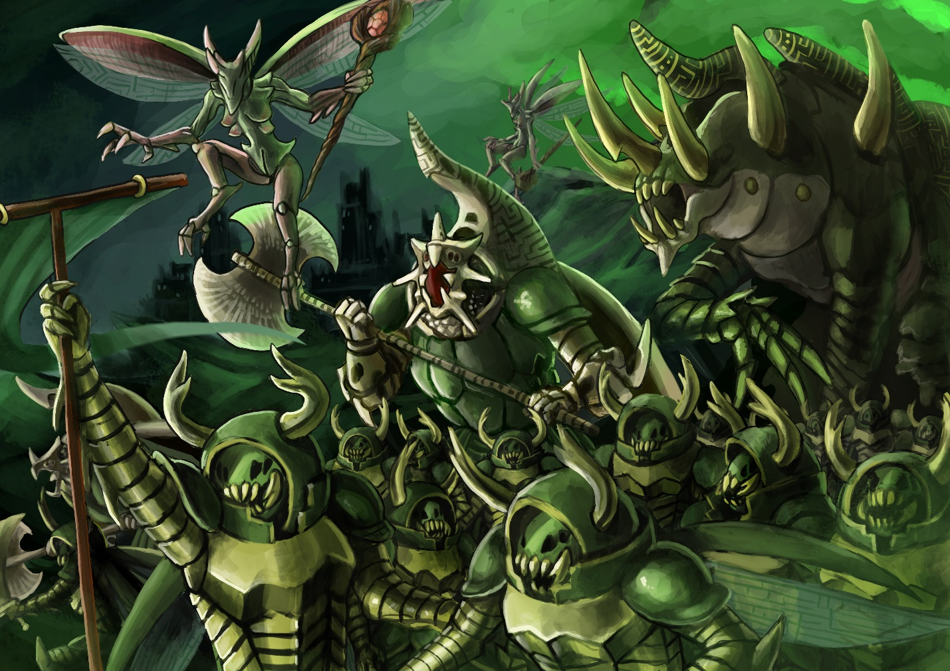

Charters

Order of the Heracleon

Stag Knight

|  |  |  |  |  |  |  |  |
| --- | --- | --- | --- | --- | --- | --- | --- |
| MC | AC | T | P | W | A | F | Cost |
| 1 | 2 | 5 | 5 | 20 | 0 | 0 | 20 |

**Upgrades:**

*For 5 points apiece, this unit may gain Flying and +1A*

**Abilities:**

*Relentless 1*: This unit may ignore one Attack Penalty Level

*Dauntless 1:* This unit may ignore one Movement Penalty Level

The Stag Knight is the core of the Hive Court military forces. Each Knight stands between 3 and 4 meters tall and is covered in a thick metallic carapace. Bred for war, the Stag Knight’s exoskeletons are coated in a light flexible steel. Experienced Knights can be gifted with honorary sigil runes by Emissaries of the Queen.

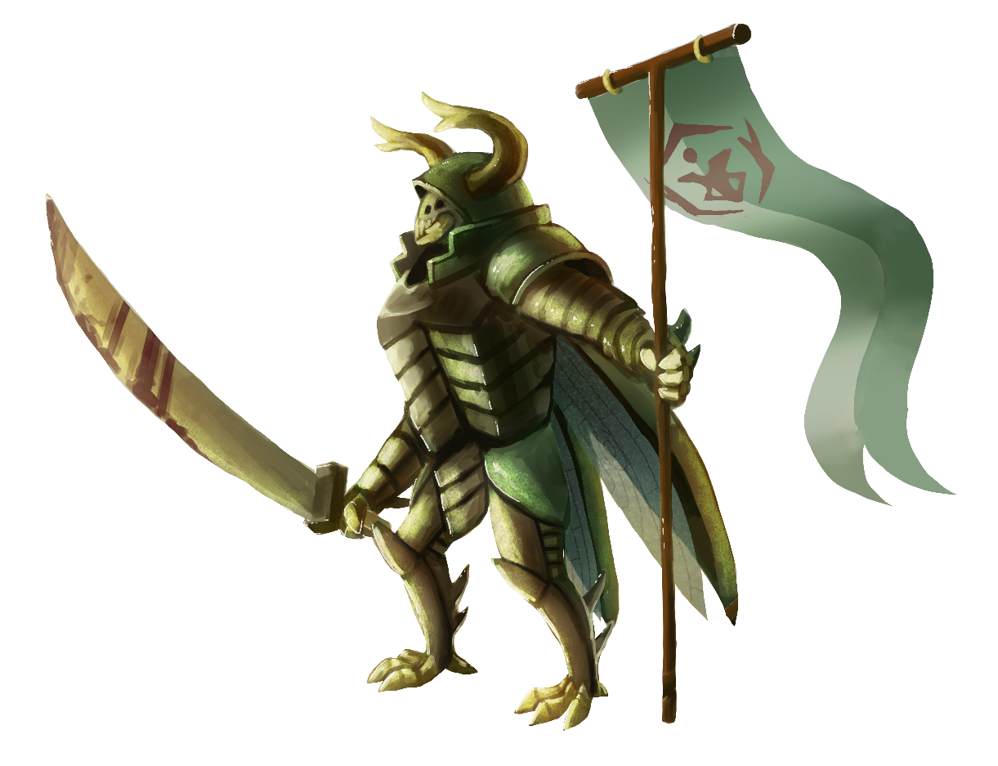 Stag Knights usually remain within the hive, though it isn’t uncommon for squads of them to be given tasks abroad. Stag Knights are high paragons of virtue, and almost all of them are sworn to a charter and an oath. Each charter represents a concept (courage, pragmatism, honor, victory, etc) and its members strive to always represent that virtue. Not all charters are equally represented in all Hives, but virtually all hives adhere to a similar charter system. At some point in their careers, a Knight can choose an oath to which they become bound. When a Knight feels that he is ready, he must undertake a quest which aligns with his desired oath. The quest is chosen by his Emissary and the leader of the charter. The Emissary inscribes a binding rune into his armor, forbidding him from returning until his mission is complete. Upon completion, the Stag Knight swears an oath and receives the rune of his charter and is henceforth imbued with the power of his beliefs. Oathsworn Stag Knights are capable of flight, despite their extreme size. This isn’t without downsides, as the Oathsworn is compelled to always follow his oath regardless of the circumstances.

Hercules Knight

|  |  |  |  |  |  |  |  |
| --- | --- | --- | --- | --- | --- | --- | --- |
| MC | AC | T | P | W | A | F | Cost |
| 0.8 | 2 | 7 | 7 | 40 | 2 | 0 | 50 |

**Abilities:**

*Relentless 2*: This unit may ignore up to two simultaneous Attack Penalty Levels

*Dauntless 2:* This unit may ignore up to two simultaneous Movement Penalty Levels

*Flying*

The Hercules Knight is a highly versatile combat unit used for situations where a Stag Knight will not suffice. Hercules Knights are relatively rare and are usually found guarding the innermost chambers of a Hive. Their massive frames and steeled carapaces render them almost indestructible to all but the most powerful foes.

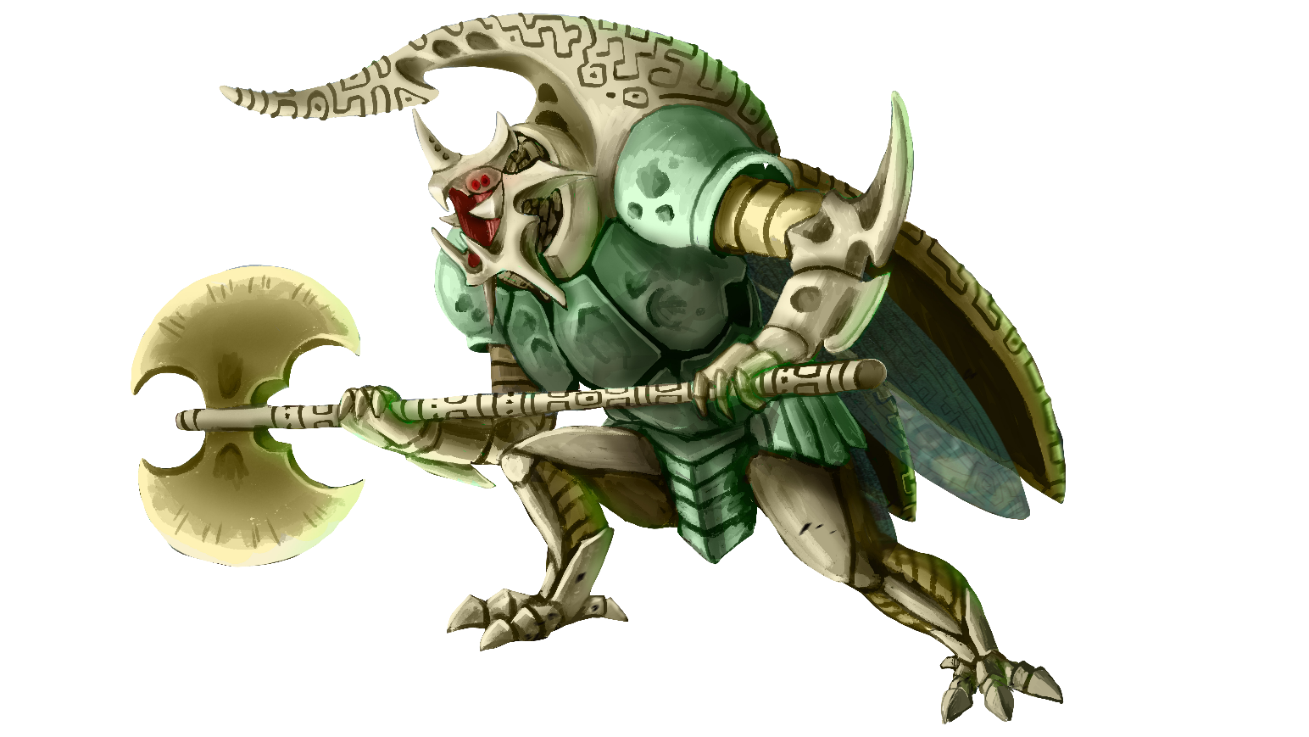A Hercules Knight is created when a Stag Knight performs acts so valorous and noteworthy that they are elevated to the High Order of the Heracleon. They may only be nominated by a Royal Emissary or the Queen herself. Such an honor is immense, for the knights of the Order are the only males permitted in the presence of the Queen. Should they be nominated, they are formed into a cocoon and begin a period of meditation and personal reflection. No two knights have the same visions, and few dare to speak of them. Not all knights are able to complete this task and are left to meditate in silence and isolation until their metamorphosis is complete. Those that do awaken are granted a new name, and their prior deeds are immortalized in the scrolls of their charter.

# Goliath

|  |  |  |  |  |  |  |  |
| --- | --- | --- | --- | --- | --- | --- | --- |
| MC | AC | T | P | W | A | F | Cost |
| 0.7 | 1.5 | 10 | 10 | 56 | 3 | 0 | 70 |

**Abilities:**

*Relentless 2*: This unit may ignore two Attack Penalty Levels

*Dauntless 2:* This unit may ignore two Movement Penalty Levels

*Flying*

*Mindless:* This unit cannot take a turn or action of its own accord, and has 0 Activation Points

*Conduit: This unit* receives twice the amount of Activation Points spent when under the effects of Royal Decree, but must be within 12” of the casting unit.

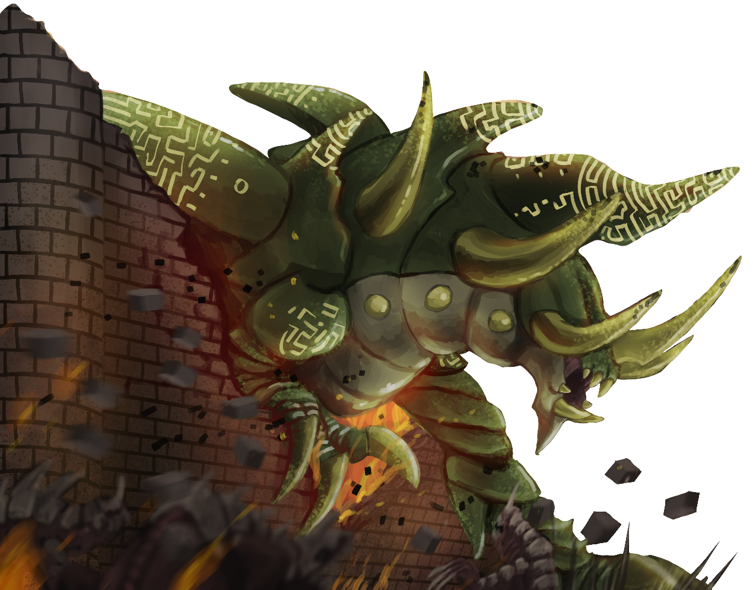 The Goliath Beetle is a monstrously large creature used in only the direst of battles. They tower easily ten meters tall over the battlefield. Primarily they are used by the Hives to break entrenched positions or to destroy the deadliest of the enemy’s war machines. The Goliath is so incredibly dangerous that the Queens do not imbue them with any sentience or will of their own. If not under direct control of the Queen or her Emissaries, the Goliath remains immobile; incapable of actions as simple as eating or drinking. Subsequently, each Goliath usually has an Emissary who is responsible for it. Because of the lack of consciousness and bond with the Emissary, Goliaths can enact the Queen’s will with a much higher degree of control and efficiency than any other part of the Hive’s military. A Goliath is created as a result of a failed Ascension Ritual. Those who become lost in their visions become empty husks, their minds filled with vanities and imagined trials. Their mighty forms continue to grow until they burst forth from the cocoon. As a penance, the Emissary who selected the Goliath becomes the Goliath’s keeper, protecting him and guiding his endless destructive force.

Hive Guard

|  |  |  |  |  |  |  |  |
| --- | --- | --- | --- | --- | --- | --- | --- |
| MC | AC | T | P | W | A | F | Cost |
| 1 | 3 | 4 | 4 | 12 | 0 | 0 | 15 |

**Abilities:**

*Flying*

Lorem ipsum dolor sit amet, consectetur adipiscing elit. Aliquam varius ligula vel tempor eleifend. Mauris nunc nulla, aliquam ac euismod at, bibendum sed sapien. Aenean nec condimentum odio. Pellentesque mauris nunc, mollis eu consectetur vitae, lobortis et ex. Aliquam pharetra, odio sit amet viverra pulvinar, velit velit rhoncus mi, et facilisis erat tortor quis risus. Quisque cursus congue sapien vel bibendum. Class aptent taciti sociosqu ad litora torquent per conubia nostra, per inceptos himenaeos. Quisque porttitor gravida condimentum. Mauris vel sollicitudin arcu. Nam eleifend dignissim libero egestas mollis. Phasellus nisi risus, viverra consequat eros quis, faucibus rhoncus massa. Cras vel leo eros.

Sed vitae ligula dapibus, interdum neque at, malesuada enim. Cras vitae nibh et libero vehicula euismod quis vel magna. Maecenas risus diam, sagittis sit amet ultrices non, hendrerit at nibh. Curabitur viverra elit vel ipsum laoreet, id hendrerit dui fringilla. Aenean finibus neque at nunc porttitor viverra. Ut facilisis ornare ex at interdum. Sed tristique, ante ac suscipit pulvinar, velit tellus placerat ligula, sed imperdiet nisi odio nec diam. Donec enim nisi, fermentum vel libero vulputate, aliquet condimentum odio. Phasellus faucibus interdum mi, nec hendrerit magna consequat quis. Mauris eget metus a nisl varius iaculis. Donec vulputate ligula vel justo tempus hendrerit. In enim augue, rutrum non pellentesque at, egestas ut ipsum. Phasellus auctor mi ut leo malesuada egestas. Vivamus in pellentesque orci, ac pulvinar mi. Curabitur vitae dictum velit.

Vestibulum nec sagittis nibh, in maximus ipsum. Suspendisse potenti. Nam non purus a magna convallis varius. Suspendisse sed felis lacus. Sed nisl massa, placerat vel est vitae, tristique dignissim dolor. Quisque feugiat sagittis lectus, ac porttitor est lobortis sed. Proin pellentesque eu erat non malesuada. Quisque fringilla in elit porta vehicula. Curabitur vel tincidunt urna. Suspendisse porta pharetra libero, sed placerat lectus pellentesque at. In sceleris

# UNIT IMAGE

Royal Emissary

|  |  |  |  |  |  |  |  |
| --- | --- | --- | --- | --- | --- | --- | --- |
| MC | AC | T | P | W | A | F | Cost |
| 1 | 3 | 4 | 3 | 16 | 1 | 2 | 20 |

**Abilities:**

*Flying*

*Spellcaster: Hive Courts*

*Royal Decree:* As an ability, this unit may expend a minimum of one Activation point to grant an immediate turn to a unit within 12”. That unit may use the spent Activation Points to take actions as though it were its turn.

*“*

The Royal Emissary is the embodiment of the Hive Queen’s will. Their primary function is to act on behalf of their Queen as a negotiator, though their ability to command the battlefield is second to none in the Hive Courts. Their light frames and powerful wings enable them to fly through the battle unhindered. However, for more spread-out skirmishes an Emissary might opt to bring a riding wasp.

A Royal Emissary may extend the Queen’s will by directly controlling Knights, granting them a considerable enhancement to their abilities. Though limited by range, this can more than make up for the Hive Court’s lack of numbers. The Emissaries maintain a vigilant watch for particularly exception knights among the units they supervise. It is their ordained role to maintain the ranks of the Heracleon by granting a select few the privilege of the Rite of Ascension. The Knights that fail their ordeal and fall to madness become bonded to the Emissary. It is the Royal Emissary’s sacred duty to keep control of their failed candidate. The exact measurements are unknown to all but the Queens themselves.

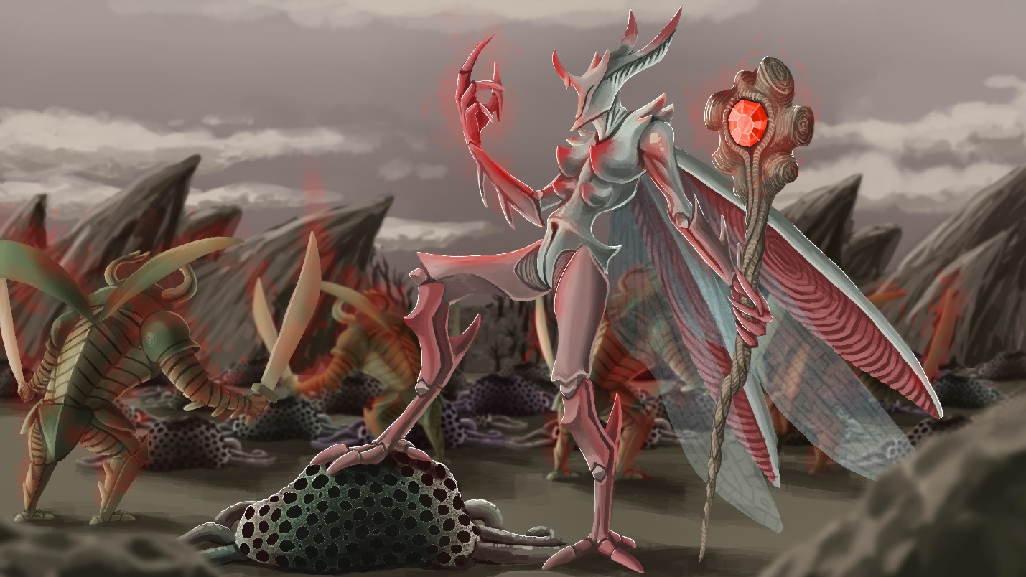

Endless Forest

Lorem ipsum dolor sit amet, consectetur adipiscing elit. Aliquam varius ligula vel tempor eleifend. Mauris nunc nulla, aliquam ac euismod at, bibendum sed sapien. Aenean nec condimentum odio. Pellentesque mauris nunc, mollis eu consectetur vitae, lobortis et ex. Aliquam pharetra, odio sit amet viverra pulvinar, velit velit rhoncus mi, et facilisis erat tortor quis risus. Quisque cursus congue sapien vel bibendum. Class aptent taciti sociosqu ad litora torquent per conubia nostra, per inceptos himenaeos. Quisque porttitor gravida condimentum. Mauris vel sollicitudin arcu. Nam eleifend dignissim libero egestas mollis. Phasellus nisi risus, viverra consequat eros quis, faucibus rhoncus massa. Cras vel leo eros.

Sed vitae ligula dapibus, interdum neque at, malesuada enim. Cras vitae nibh et libero vehicula euismod quis vel magna. Maecenas risus diam, sagittis sit amet ultrices non, hendrerit at nibh. Curabitur viverra elit vel ipsum laoreet, id hendrerit dui fringilla. Aenean finibus neque at nunc porttitor viverra. Ut facilisis ornare ex at interdum. Sed tristique, ante ac suscipit pulvinar, velit tellus placerat ligula, sed imperdiet nisi odio nec diam. Donec enim nisi, fermentum vel libero vulputate, aliquet condimentum odio. Phasellus faucibus interdum mi, nec hendrerit magna consequat quis. Mauris eget metus a nisl varius iaculis. Donec vulputate ligula vel justo tempus hendrerit. In enim augue, rutrum non pellentesque at, egestas ut ipsum. Phasellus auctor mi ut leo malesuada egestas. Vivamus in pellentesque orci, ac pulvinar mi. Curabitur vitae dictum velit.

Vestibulum nec sagittis nibh, in maximus ipsum. Suspendisse potenti. Nam non purus a magna convallis varius. Suspendisse sed felis lacus. Sed nisl massa, placerat vel est vitae, tristique dignissim dolor. Quisque feugiat sagittis lectus, ac porttitor est lobortis sed. Proin pellentesque eu erat non malesuada. Quisque fringilla in elit porta vehicula. Curabitur vel tincidunt urna. Suspendisse porta pharetra libero, sed placerat lectus pellentesque at. In sceleris

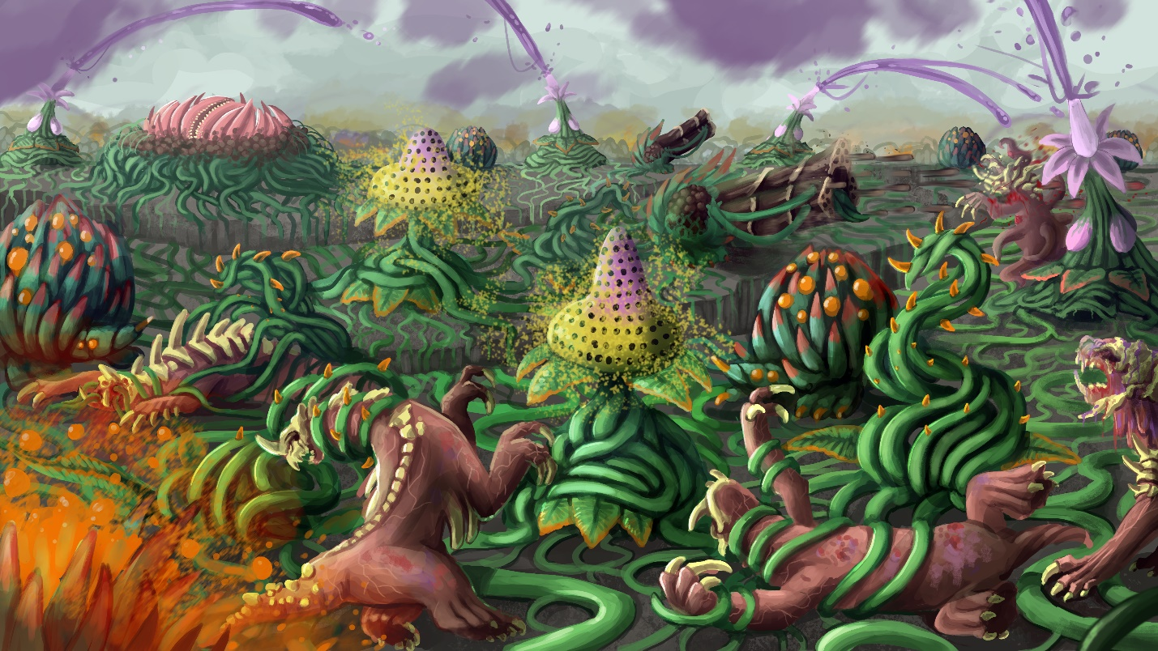

Root Cluster

|  |  |  |  |  |  |  |  |
| --- | --- | --- | --- | --- | --- | --- | --- |
| MC | AC | T | P | W | A | F | Cost |
| - | - | 1 | - | 1 | 0 | 2 | 5 |

**Abilities:**

*Root*: The unit is malleable and can be recreated and changed by other units. X represents the current level.

*Seed 12*: The unit is malleable and can be recreated and changed by other units. X represents the current level.

Lorem ipsum dolor sit amet, consectetur adipiscing elit. Aliquam varius ligula vel tempor eleifend. Mauris nunc nulla, aliquam ac euismod at, bibendum sed sapien. Aenean nec condimentum odio. Pellentesque mauris nunc, mollis eu consectetur vitae, lobortis et ex. Aliquam pharetra, odio sit amet viverra pulvinar, velit velit rhoncus mi, et facilisis erat tortor quis risus. Quisque cursus congue sapien vel bibendum. Class aptent taciti sociosqu ad litora torquent per conubia nostra, per inceptos himenaeos. Quisque porttitor gravida condimentum. Mauris vel sollicitudin arcu. Nam eleifend dignissim libero egestas mollis. Phasellus nisi risus, viverra consequat eros quis, faucibus rhoncus massa. Cras vel leo eros.

Sed vitae ligula dapibus, interdum neque at, malesuada enim. Cras vitae nibh et libero vehicula euismod quis vel magna. Maecenas risus diam, sagittis sit amet ultrices non, hendrerit at nibh. Curabitur viverra elit vel ipsum laoreet, id hendrerit dui fringilla. Aenean finibus neque at nunc porttitor viverra. Ut facilisis ornare ex at interdum. Sed tristique, ante ac suscipit pulvinar, velit tellus placerat ligula, sed imperdiet nisi odio nec diam. Donec enim nisi, fermentum vel libero vulputate, aliquet condimentum odio. Phasellus faucibus interdum mi, nec hendrerit magna consequat quis. Mauris eget metus a nisl varius iaculis. Donec vulputate ligula vel justo tempus hendrerit. In enim augue, rutrum non pellentesque at, egestas ut ipsum. Phasellus auctor mi ut leo malesuada egestas. Vivamus in pellentesque orci, ac pulvinar mi. Curabitur vitae dictum velit.

Vestibulum nec sagittis nibh, in maximus ipsum. Suspendisse potenti. Nam non purus a magna convallis varius. Suspendisse sed felis lacus. Sed nisl massa, placerat vel est vitae, tristique dignissim dolor. Quisque feugiat sagittis lectus, ac porttitor est lobortis sed. Proin pellentesque eu erat non malesuada. Quisque fringilla in elit porta vehicula. Curabitur vel tincidunt urna. Suspendisse porta pharetra libero, sed placerat lectus pellentesque at. In sceleris

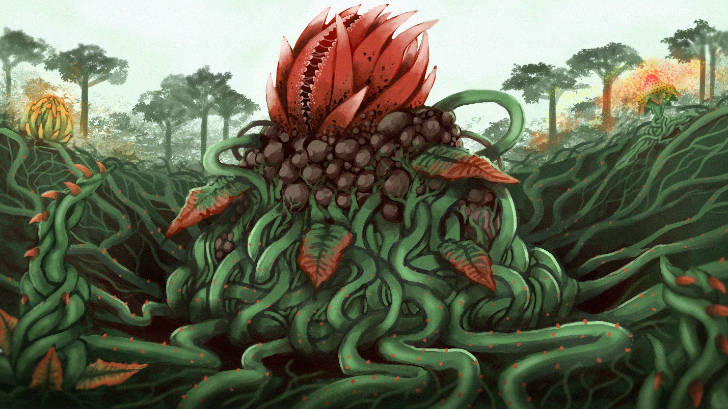

Lashvine

|  |  |  |  |  |  |  |  |
| --- | --- | --- | --- | --- | --- | --- | --- |
| MC | AC | T | P | W | A | F | Cost |
| 2 | 3 | 2 | 3 | 8 | 0 | 0 | 10 |

**Abilities:**

*Root*: The unit is malleable and can be recreated and changed by other units. X represents the current level.

*Seed 12*: The unit is malleable and can be recreated and changed by other units. X represents the current level.

Lorem ipsum dolor sit amet, consectetur adipiscing elit. Aliquam varius ligula vel tempor eleifend. Mauris nunc nulla, aliquam ac euismod at, bibendum sed sapien. Aenean nec condimentum odio. Pellentesque mauris nunc, mollis eu consectetur vitae, lobortis et ex. Aliquam pharetra, odio sit amet viverra pulvinar, velit velit rhoncus mi, et facilisis erat tortor quis risus. Quisque cursus congue sapien vel bibendum. Class aptent taciti sociosqu ad litora torquent per conubia nostra, per inceptos himenaeos. Quisque porttitor gravida condimentum. Mauris vel sollicitudin arcu. Nam eleifend dignissim libero egestas mollis. Phasellus nisi risus, viverra consequat eros quis, faucibus rhoncus massa. Cras vel leo eros.

Sed vitae ligula dapibus, interdum neque at, malesuada enim. Cras vitae nibh et libero vehicula euismod quis vel magna. Maecenas risus diam, sagittis sit amet ultrices non, hendrerit at nibh. Curabitur viverra elit vel ipsum laoreet, id hendrerit dui fringilla. Aenean finibus neque at nunc porttitor viverra. Ut facilisis ornare ex at interdum. Sed tristique, ante ac suscipit pulvinar, velit tellus placerat ligula, sed imperdiet nisi odio nec diam. Donec enim nisi, fermentum vel libero vulputate, aliquet condimentum odio. Phasellus faucibus interdum mi, nec hendrerit magna consequat quis. Mauris eget metus a nisl varius iaculis. Donec vulputate ligula vel justo tempus hendrerit. In enim augue, rutrum non pellentesque at, egestas ut ipsum. Phasellus auctor mi ut leo malesuada egestas. Vivamus in pellentesque orci, ac pulvinar mi. Curabitur vitae dictum velit.

Vestibulum nec sagittis nibh, in maximus ipsum. Suspendisse potenti. Nam non purus a magna convallis varius. Suspendisse sed felis lacus. Sed nisl massa, placerat vel est vitae, tristique dignissim dolor. Quisque feugiat sagittis lectus, ac porttitor est lobortis sed. Proin pellentesque eu erat non malesuada. Quisque fringilla in elit porta vehicula. Curabitur vel tincidunt urna. Suspendisse porta pharetra libero, sed placerat lectus pellentesque at. In sceleris

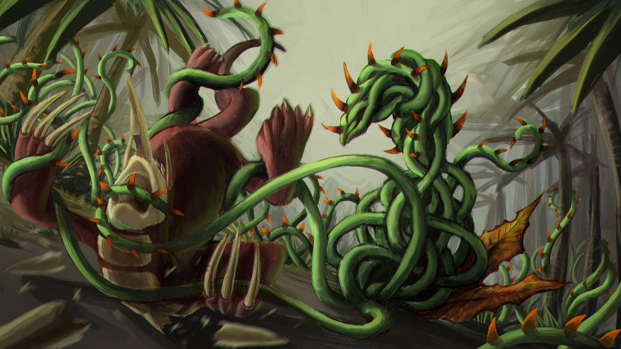

Cloudsower

|  |  |  |  |  |  |  |  |
| --- | --- | --- | --- | --- | --- | --- | --- |
| MC | AC | T | P | W | A | F | Cost |
| 1 | 3 | 2 | 2 | 6 | 0 | 2 | 7 |

**Abilities:**

*Root*: The unit is malleable and can be recreated and changed by other units. X represents the current level.

*Seed 12*: The unit is malleable and can be recreated and changed by other units. X represents the current level.

Lorem ipsum dolor sit amet, consectetur adipiscing elit. Aliquam varius ligula vel tempor eleifend. Mauris nunc nulla, aliquam ac euismod at, bibendum sed sapien. Aenean nec condimentum odio. Pellentesque mauris nunc, mollis eu consectetur vitae, lobortis et ex. Aliquam pharetra, odio sit amet viverra pulvinar, velit velit rhoncus mi, et facilisis erat tortor quis risus. Quisque cursus congue sapien vel bibendum. Class aptent taciti sociosqu ad litora torquent per conubia nostra, per inceptos himenaeos. Quisque porttitor gravida condimentum. Mauris vel sollicitudin arcu. Nam eleifend dignissim libero egestas mollis. Phasellus nisi risus, viverra consequat eros quis, faucibus rhoncus massa. Cras vel leo eros.

Sed vitae ligula dapibus, interdum neque at, malesuada enim. Cras vitae nibh et libero vehicula euismod quis vel magna. Maecenas risus diam, sagittis sit amet ultrices non, hendrerit at nibh. Curabitur viverra elit vel ipsum laoreet, id hendrerit dui fringilla. Aenean finibus neque at nunc porttitor viverra. Ut facilisis ornare ex at interdum. Sed tristique, ante ac suscipit pulvinar, velit tellus placerat ligula, sed imperdiet nisi odio nec diam. Donec enim nisi, fermentum vel libero vulputate, aliquet condimentum odio. Phasellus faucibus interdum mi, nec hendrerit magna consequat quis. Mauris eget metus a nisl varius iaculis. Donec vulputate ligula vel justo tempus hendrerit. In enim augue, rutrum non pellentesque at, egestas ut ipsum. Phasellus auctor mi ut leo malesuada egestas. Vivamus in pellentesque orci, ac pulvinar mi. Curabitur vitae dictum velit.

Vestibulum nec sagittis nibh, in maximus ipsum. Suspendisse potenti. Nam non purus a magna convallis varius. Suspendisse sed felis lacus. Sed nisl massa, placerat vel est vitae, tristique dignissim dolor. Quisque feugiat sagittis lectus, ac porttitor est lobortis sed. Proin pellentesque eu erat non malesuada. Quisque fringilla in elit porta vehicula. Curabitur vel tincidunt urna. Suspendisse porta pharetra libero, sed placerat lectus pellentesque at. In sceleris

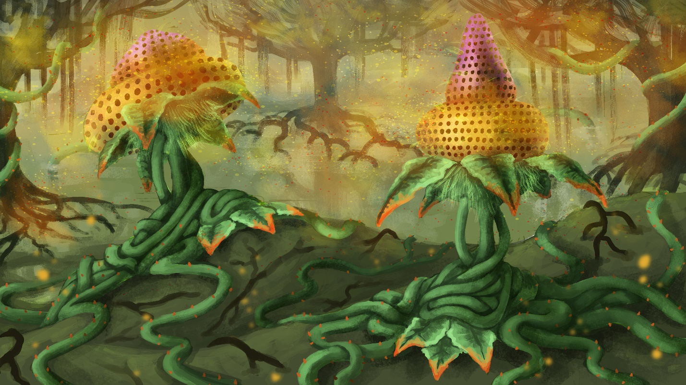

Mine Plant

|  |  |  |  |  |  |  |  |
| --- | --- | --- | --- | --- | --- | --- | --- |
| MC | AC | T | P | W | A | F | Cost |
| 1 | 3 | 2 | 2 | 6 | 0 | 2 | 7 |

**Abilities:**

*Root*: The unit is malleable and can be recreated and changed by other units. X represents the current level.

*Seed 12*: The unit is malleable and can be recreated and changed by other units. X represents the current level.

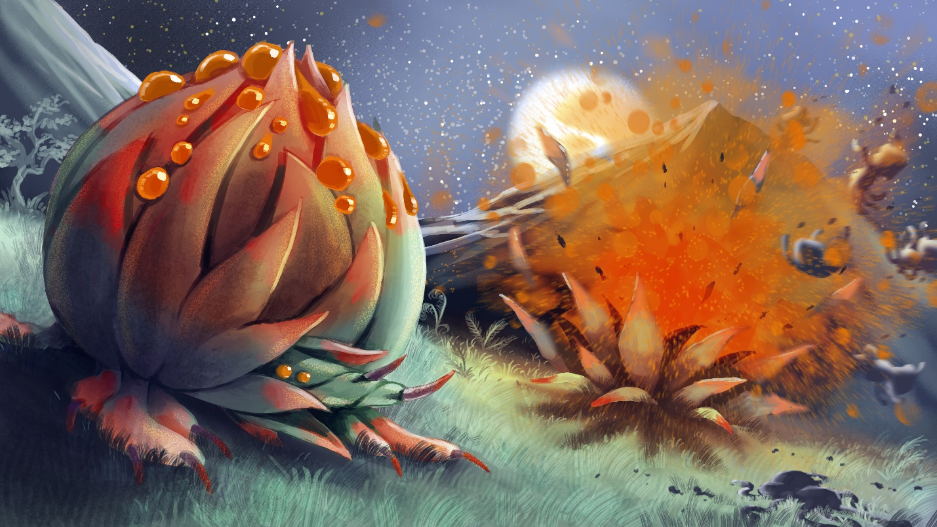The Mine Plant is a dangerous evolution in the forces of the Verdant Tide. When a defensive position is required, it is common to see ranks of bulbous Mine Plants growing in front of Lashvines. The Mine Plant detonates when an enemy approaches, blasting them with tightly compressed gas and bile. After bursting, the Mine Plant leaves behind a Root Cluster in its place. Their fast rate of growth means that an entrenched position can quickly become suicidal to assault if not quickly dispensed. They are vulnerable to flight, however. Their ability to detonate is dependent upon sensing the vibrations in the ground, so if their would-be prey doesn’t take a step or flies, it can avoid the attack entirely.

Cannon Plant

|  |  |  |  |  |  |  |  |
| --- | --- | --- | --- | --- | --- | --- | --- |
| MC | AC | T | P | W | A | F | Cost |
| 2 | 6 | 2 | 3 | 8 | 0 | 0 | 10 |

**Abilities:**

*Root*: The unit is malleable and can be recreated and changed by other units. X represents the current level.

*Seed 12*: The unit is malleable and can be recreated and changed by other units. X represents the current level.

*True Damage 3*: The unit cannot inflict fewer than three points of damage per Attack.

Lorem ipsum dolor sit amet, consectetur adipiscing elit. Aliquam varius ligula vel tempor eleifend. Mauris nunc nulla, aliquam ac euismod at, bibendum sed sapien. Aenean nec condimentum odio. Pellentesque mauris nunc, mollis eu consectetur vitae, lobortis et ex. Aliquam pharetra, odio sit amet viverra pulvinar, velit velit rhoncus mi, et facilisis erat tortor quis risus. Quisque cursus congue sapien vel bibendum. Class aptent taciti sociosqu ad litora torquent per conubia nostra, per inceptos himenaeos. Quisque porttitor gravida condimentum. Mauris vel sollicitudin arcu. Nam eleifend dignissim libero egestas mollis. Phasellus nisi risus, viverra consequat eros quis, faucibus rhoncus massa. Cras vel leo eros.

Sed vitae ligula dapibus, interdum neque at, malesuada enim. Cras vitae nibh et libero vehicula euismod quis vel magna. Maecenas risus diam, sagittis sit amet ultrices non, hendrerit at nibh. Curabitur viverra elit vel ipsum laoreet, id hendrerit dui fringilla. Aenean finibus neque at nunc porttitor viverra. Ut facilisis ornare ex at interdum. Sed tristique, ante ac suscipit pulvinar, velit tellus placerat ligula, sed imperdiet nisi odio nec diam. Donec enim nisi, fermentum vel libero vulputate, aliquet condimentum odio. Phasellus faucibus interdum mi, nec hendrerit magna consequat quis. Mauris eget metus a nisl varius iaculis. Donec vulputate ligula vel justo tempus hendrerit. In enim augue, rutrum non pellentesque at, egestas ut ipsum. Phasellus auctor mi ut leo malesuada egestas. Vivamus in pellentesque orci, ac pulvinar mi. Curabitur vitae dictum velit.

Vestibulum nec sagittis nibh, in maximus ipsum. Suspendisse potenti. Nam non purus a magna convallis varius. Suspendisse sed felis lacus. Sed nisl massa, placerat vel est vitae, tristique dignissim dolor. Quisque feugiat sagittis lectus, ac porttitor est lobortis sed. Proin pellentesque eu erat non malesuada. Quisque fringilla in elit porta vehicula. Curabitur vel tincidunt urna. Suspendisse porta pharetra libero, sed placerat lectus pellentesque at. In sceleris

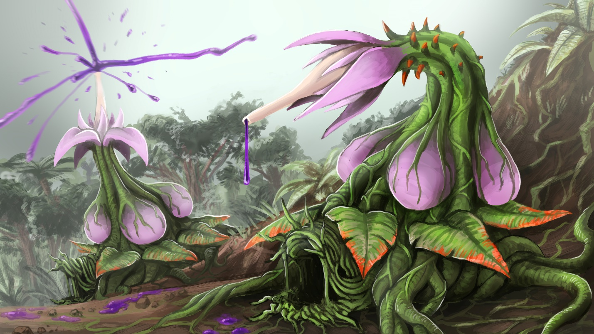

Seedblower

|  |  |  |  |  |  |  |  |
| --- | --- | --- | --- | --- | --- | --- | --- |
| MC | AC | T | P | W | A | F | Cost |
| 1 | 3 | 2 | 2 | 6 | 0 | 2 | 7 |

**Abilities:**

*Root*: The unit is malleable and can be recreated and changed by other units. X represents the current level.

*Seed 12*: The unit is malleable and can be recreated and changed by other units. X represents the current level.

Lorem ipsum dolor sit amet, consectetur adipiscing elit. Aliquam varius ligula vel tempor eleifend. Mauris nunc nulla, aliquam ac euismod at, bibendum sed sapien. Aenean nec condimentum odio. Pellentesque mauris nunc, mollis eu consectetur vitae, lobortis et ex. Aliquam pharetra, odio sit amet viverra pulvinar, velit velit rhoncus mi, et facilisis erat tortor quis risus. Quisque cursus congue sapien vel bibendum. Class aptent taciti sociosqu ad litora torquent per conubia nostra, per inceptos himenaeos. Quisque porttitor gravida condimentum. Mauris vel sollicitudin arcu. Nam eleifend dignissim libero egestas mollis. Phasellus nisi risus, viverra consequat eros quis, faucibus rhoncus massa. Cras vel leo eros.

Sed vitae ligula dapibus, interdum neque at, malesuada enim. Cras vitae nibh et libero vehicula euismod quis vel magna. Maecenas risus diam, sagittis sit amet ultrices non, hendrerit at nibh. Curabitur viverra elit vel ipsum laoreet, id hendrerit dui fringilla. Aenean finibus neque at nunc porttitor viverra. Ut facilisis ornare ex at interdum. Sed tristique, ante ac suscipit pulvinar, velit tellus placerat ligula, sed imperdiet nisi odio nec diam. Donec enim nisi, fermentum vel libero vulputate, aliquet condimentum odio. Phasellus faucibus interdum mi, nec hendrerit magna consequat quis. Mauris eget metus a nisl varius iaculis. Donec vulputate ligula vel justo tempus hendrerit. In enim augue, rutrum non pellentesque at, egestas ut ipsum. Phasellus auctor mi ut leo malesuada egestas. Vivamus in pellentesque orci, ac pulvinar mi. Curabitur vitae dictum velit.

Vestibulum nec sagittis nibh, in maximus ipsum. Suspendisse potenti. Nam non purus a magna convallis varius. Suspendisse sed felis lacus. Sed nisl massa, placerat vel est vitae, tristique dignissim dolor. Quisque feugiat sagittis lectus, ac porttitor est lobortis sed. Proin pellentesque eu erat non malesuada. Quisque fringilla in elit porta vehicula. Curabitur vel tincidunt urna. Suspendisse porta pharetra libero, sed placerat lectus pellentesque at. In sceleris

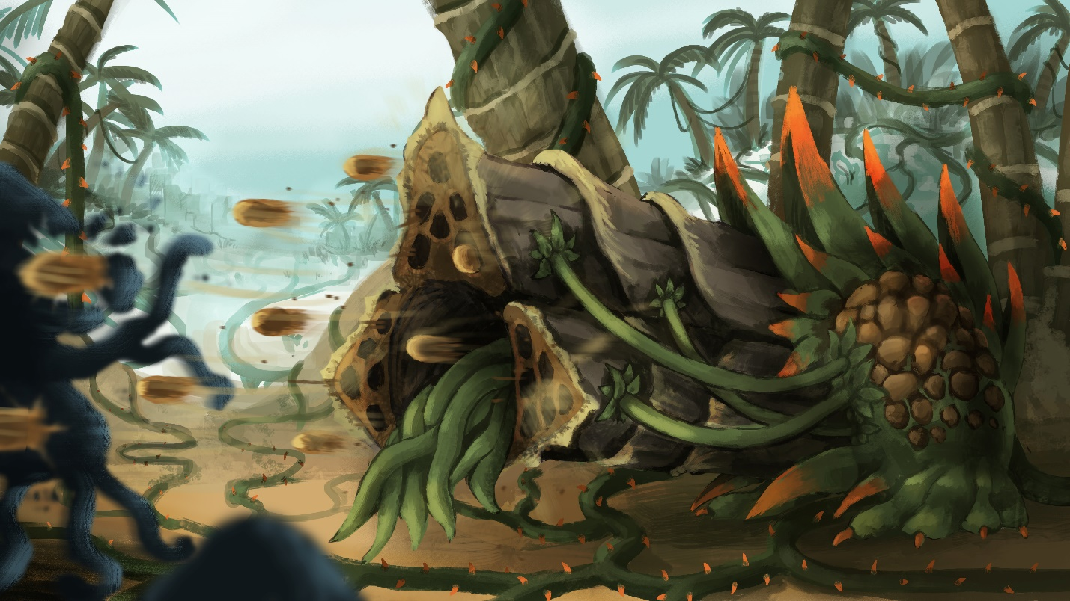

Treant

|  |  |  |  |  |  |  |  |
| --- | --- | --- | --- | --- | --- | --- | --- |
| MC | AC | T | P | W | A | F | Cost |
| 1 | 3 | 2 | 2 | 6 | 0 | 2 | 7 |

**Abilities:**

*Reshape 3*: The unit is malleable and can be recreated and changed by other units. X represents the current level.

Lorem ipsum dolor sit amet, consectetur adipiscing elit. Aliquam varius ligula vel tempor eleifend. Mauris nunc nulla, aliquam ac euismod at, bibendum sed sapien. Aenean nec condimentum odio. Pellentesque mauris nunc, mollis eu consectetur vitae, lobortis et ex. Aliquam pharetra, odio sit amet viverra pulvinar, velit velit rhoncus mi, et facilisis erat tortor quis risus. Quisque cursus congue sapien vel bibendum. Class aptent taciti sociosqu ad litora torquent per conubia nostra, per inceptos himenaeos. Quisque porttitor gravida condimentum. Mauris vel sollicitudin arcu. Nam eleifend dignissim libero egestas mollis. Phasellus nisi risus, viverra consequat eros quis, faucibus rhoncus massa. Cras vel leo eros.

Sed vitae ligula dapibus, interdum neque at, malesuada enim. Cras vitae nibh et libero vehicula euismod quis vel magna. Maecenas risus diam, sagittis sit amet ultrices non, hendrerit at nibh. Curabitur viverra elit vel ipsum laoreet, id hendrerit dui fringilla. Aenean finibus neque at nunc porttitor viverra. Ut facilisis ornare ex at interdum. Sed tristique, ante ac suscipit pulvinar, velit tellus placerat ligula, sed imperdiet nisi odio nec diam. Donec enim nisi, fermentum vel libero vulputate, aliquet condimentum odio. Phasellus faucibus interdum mi, nec hendrerit magna consequat quis. Mauris eget metus a nisl varius iaculis. Donec vulputate ligula vel justo tempus hendrerit. In enim augue, rutrum non pellentesque at, egestas ut ipsum. Phasellus auctor mi ut leo malesuada egestas. Vivamus in pellentesque orci, ac pulvinar mi. Curabitur vitae dictum velit.

Vestibulum nec sagittis nibh, in maximus ipsum. Suspendisse potenti. Nam non purus a magna convallis varius. Suspendisse sed felis lacus. Sed nisl massa, placerat vel est vitae, tristique dignissim dolor. Quisque feugiat sagittis lectus, ac porttitor est lobortis sed. Proin pellentesque eu erat non malesuada. Quisque fringilla in elit porta vehicula. Curabitur vel tincidunt urna. Suspendisse porta pharetra libero, sed placerat lectus pellentesque at. In sceleris

Fleshcrafter Priests

The Fleshcrafter Priests and their fetid fields are all that remains of the shattered glory of the once-great legacy of Man. Millions of years before the present day in-game, mankind reached a societal zenith thanks to his understanding of the arcane arts. Men had learned to access and use the magical energies in “ley lines” flowing unseen through the world. Over thousands of years of use, man slowly evolved to become more linked to this energy - and to one another. People began exhibiting minor telepathic innate abilities, as well as increased rates of mutation and arcane abilities. However, not all humans had the same degree of faith in the increasingly-unstable lines of energy. These Biomancers avoided touching leyline energy directly, instead focusing on healing and augmentative spells. Biomancy involved the use of “Animus”, or the human spirit. The human spirit had become so intertwined with the leylines that mankind’s Animus itself became a source of power. By accessing the latent energies within a person or within themselves, they could perform great feats of restoration and enhancement.

At one point, man went too far in his search for knowledge and power. In an experiment gone awry, the Animus-leyline bridge was overwhelmed and the undercurrents of magic merged with the Animus of man. Instantly, virtually all the souls of the human race were merged into a giant collective, streaming and flowing through the leylines. The human’s bodies were warped and disfigured by the overwhelming amount of energy coursing through them. The lucky ones died instantly, while some were morphed into piles of barely-functional flesh or soul-less husks in the shape of men. Due to their high degree of connection to the elements and leylines, many people fused with the Earth itself. Instead of grass, dirt, and trees there were endless fields of hair, flesh, and bone. Not all was lost though.

The greatest of the Biomancers had managed to protect themselves through limited leyline access and mastery of Animus, though they weren’t completely unaffected. They emerged from their protective warrens and shelters to a nightmare world they could barely fathom, driving many of them to madness. Realizing that they and other scattered conclaves were likely the only remains of the human race, they set to trying to fix things. Though they hadn’t been reconstituted or stripped of their Animus, the Biomancers found that their prior abilities were far stronger. They found that they could easily reshape the living terrain that had once been their people back into men, but the results were hollow. The restored bodies were lacking virtually all Animus, and so were little more than unthinking animals. A man couldn’t be created unless a complete Animus was gathered. Nonetheless, they pushed on, until a curious discovery was made; the Biomancers didn’t age. Initially this seemed to be a boon. What had been a problem constrained to decades now became open-ended. Unable to access the leylines, and with no immediate solution they settled in and began their long work. The decades turned to centuries, and the centuries turned to millennia. At first they tried to retain the remnants of their old civilization. But with such limited numbers and abilities, they inevitably failed. With no masons, the buildings crumbled. With no craftsman, the ability to produce even pig iron began to fade. Eventually the distasteful decision was made to begin utilizing the flesh fields for labor and resources. Countless millennia dragged on, taking a constant toll on the shrinking remnants of the human race. An eternity of memories and almost constant failure drove almost all of them to madness. Their duties became rites and their mission a catechism. No longer mages or academics, they became Priests. And thus we arrive at the present.

The domains of the Fleshcrafter Priests are the stuff of nightmares. Endless fields of writhing flesh. Prairies of hair filled with enormous parasites. Misshapen mouths open and close mindlessly, eager to devour anything that approaches. The Flesh Fields are filled with the steady hum and drone of thousands of mouths crying, groaning, and whimpering. The regions are also patrolled by all sorts of abominations and twisted creatures tailor-made by the Priests to defend their territories. The Priests themselves are almost to a man completely mad. None seem to recall what mankind looked like, or how the state of things came to be. All that persists is the desire to restore humanity. While the individual Priest’s goals and means may vary; the most common means are via growing the fields, acquiring biomass and harvesting Animus to attempt to recreate souls.

# Fleshcrafter Society

Fleshcrafter Priests live solitary lives. While there are exceptions, most of them prefer to remain in their own territory tending to their fields and pursuing their arcane goals. Occasionally different Priests band together into groups or alliances, but more often than not their vastly different ends make working together precarious at best. In addition, their lack of sanity makes any alliance with them particularly ephemeral.

It is hard to accidentally find yourself within the domain of a Fleshcrafter Priest. The ground underfoot is slick with oil, pus, and blood. Wails and laughter travel through the air, crying out from various toothy mouths littering the landscape. The stench from musk and pools of excrement are choking. On the periphery, wolves and various other scavengers pick at the ever-expanding flesh which sweeps over and encompasses the terrain.

# Emperor Al-Khazul

One of the greatest lords of the Fleshcrafters is the High Emperor Al-Khazul. A master of transmutation, and self-proclaimed Emperor of Man. He rules from his city, Khazul, with his prized treasure Romulus. Throughout his ages of conquest and experimentation, Al-Khazul was able to gather and synthesize a complete human soul. This is an almost-unimaginable feat, in which he takes great pride and his enemies take bitter resentment. The soul he has named Romulus, and he keeps it close to him at all times. Romulus’ life is an unpleasant one, living forever in an ever-shifting body as Al-Khazul’s whims and needs change. Al-Khazul sits at the center of his fortified city, entertaining himself by watching his homunculi go about their pre-planned business. He considers himself to be a pragmatic monarch ruling his people, and is generally a respected, but always feared, figure.

# Khazul

Khazul is the seat of Emperor Al-Khazul’s vast empire. The city itself is a profane construct of blood, flesh, and bone. Despite this, its scale and fortifications rival the greatest of the Hivekeeps. The city is populated with thousands of homunculi, each moving in accordance with its instructions granted at creation. The walls of the city are covered with ears and eyes, so that Emperor Al-Khazul can see and hear anywhere from multiple angles. Intruders in the city never make it far, even if they do mange to penetrate the defenses. The many layers of surveillance immediately catch intruders, and all the “citizens” quickly converge on the area to destroy the intruder, with a single-minded ferocity.

Fleshcrafter Priest

|  |  |  |  |  |  |  |  |
| --- | --- | --- | --- | --- | --- | --- | --- |
| MC | AC | T | P | W | A | F | Cost |
| 1 | 3 | 4 | 4 | 20 | 0 | 4 | 20 |

**Abilities:** Spellcaster: Fleshcraft, Reshape 1,

You may only field one Fleshcrafter Priest in your force

*Adaptable*: When selecting this model, you may pay 10 +(X*5) additional points, where X = (current Reshape level -1) to increase this model's Reshape level by one. This ability may be used multiple times, but it must be used one use at a time. (IE: You must upgrade from Reshape 1 to Reshape 2 to Reshape 3. You cannot upgrade directly from Reshape 1 to Reshape 3)

*Knit Flesh*: Spend X Activation Points to cast this spell. You may restore twice X Wounds on a friendly unit within 24”.

*Combine*: Choose up to 2 models within 3” of one another. Remove them from the table and put in a new model whose Reshape level is the sum of the removed models. It must be placed in a spot within 3” of where both models were standing. (You select only one model with this ability) COST: 6 Activation Points RANGE: 18”

*Break Apart*: Select a friendly unit within 18”. You may remove it from the battlefield and place 2 models within 3” of the removed model. The two new models must have a combined Reshape level equal to the sacrificed model. COST: 6 Activation Points

*“The masters of Mankind. Some of us remember a time when such a title would be used with scorn. Those were dark days, and we ascended to glorious divinity from the darkness. Now everything we’ve sought stands before us, threatening everything we’ve thus acquired. We’ve persevered since The Turn, and we won’t be deterred. Let us show them what it means to be a member of the Ministry of Flesh!”*

*-High Chaplain Reinhardt*

Fleshcrafter Priests are ancient biomancers, each controlling and shepherding vast swathes of mutagenic flesh. They are capable of freely manipulating their herd into virtually any shape they want. Most of them initially desired the restoration of the human race. However, the intervening eons have long since degraded their memories and minds. Most no longer even remembering what humans looked like. Some Priests have lost their sense of self entirely and simply live as a singular enormous living colony. Many view themselves as deities or see themselves as clerics protecting their flock.

No two Fleshcrafter Priests will look identical. Their ability to reshape and reknit flesh doesn’t stop at their minions; they are just as adept at manipulating their own forms. They are capable of quickly changing their shape and those of their minions. They can even combine or break apart their creations 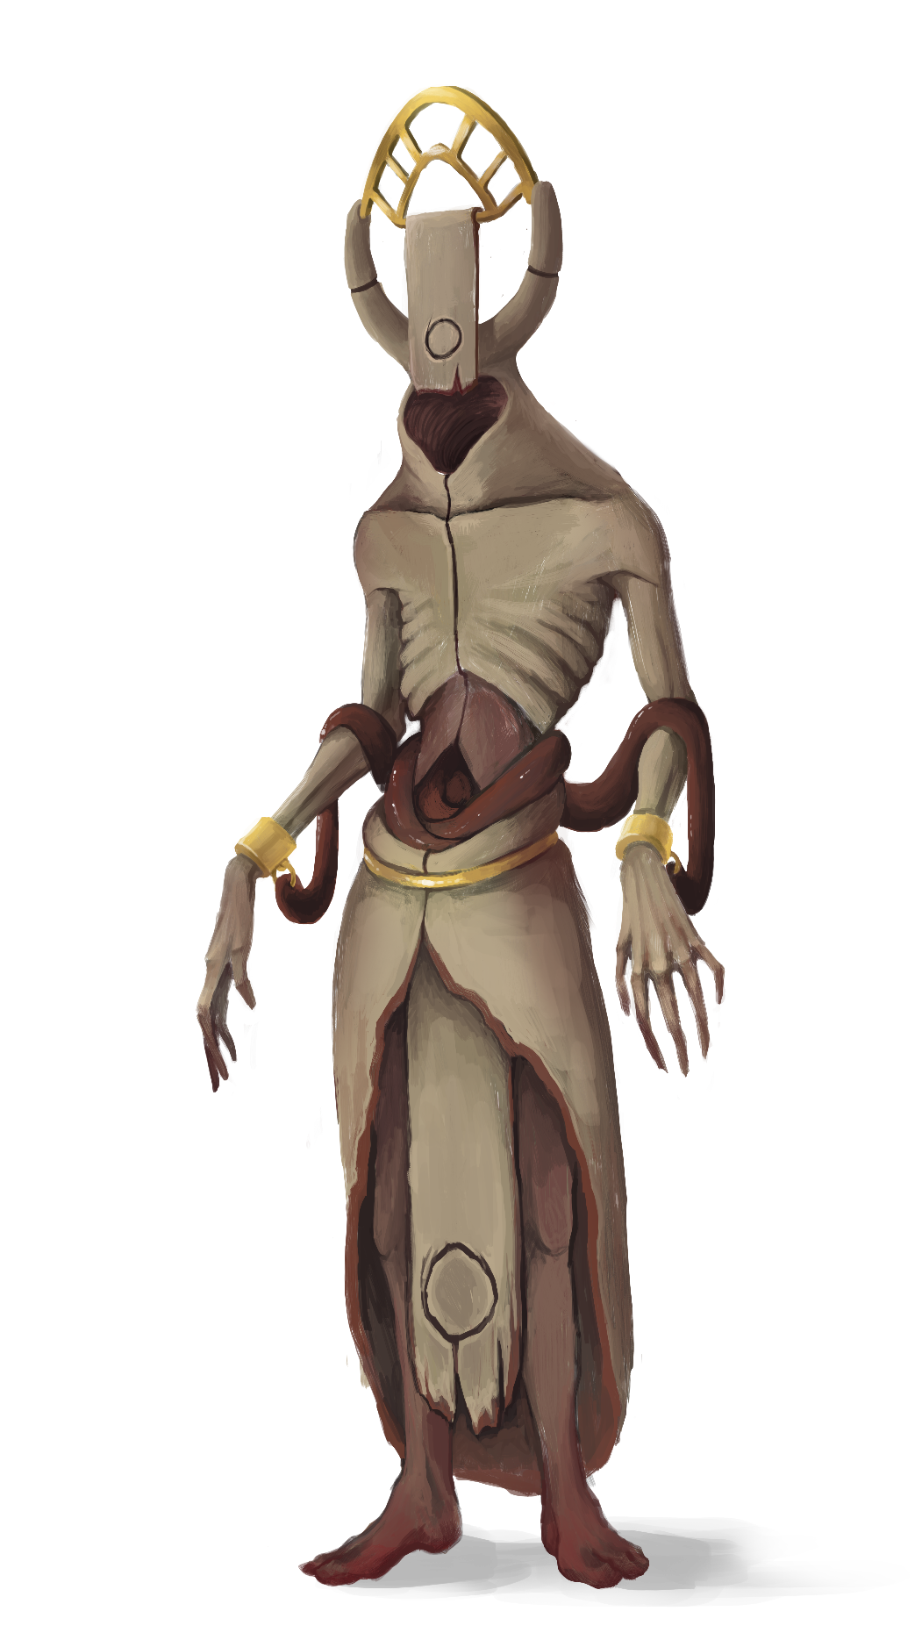to rebuild their army in an instant. As biomancers, they are powerful healers, and can easily support their warriors in the field. Fleshcrafter Priests act as the focal point for their armies, and proper use of their abilities can turn a defeat into a victory. By breaking apart and reforming their army, Priests are capable of adapting to any battlefield circumstance.

-

Homunculus

|  |  |  |  |  |  |  |  |
| --- | --- | --- | --- | --- | --- | --- | --- |
| MC | AC | T | P | W | A | F | Cost |
| 3 | - | 1 | 0 | 1 | 0 | 0 | - |

**Abilities:**

*Reshape 0*

At the bottom of the pecking order is the lowly Homunculus. The Homunculus is little more than a lump of living flesh. They serve as scavengers and entertainment for Priests. After an expedition into the Flesh Fields is felled, a swarm of Homunculi always quickly arrives to tear up and strip down the unfortunate foes. One by one, the corpses are stripped and thrown into the great maws littering the terrain. These creatures don’t have much combat usefulness, but they can serve as graft material. A wise Priest can quickly shift their forces around the battlefield via crafty use of Homunculi.



Flesh Drone

|  |  |  |  |  |  |  |  |
| --- | --- | --- | --- | --- | --- | --- | --- |
| MC | AC | T | P | W | A | F | Cost |
| 1 | 3 | 3 | 3 | 8 | 0 | 1 | 10 |

**Abilities:**

*Reshape 1*: The unit is malleable and can be recreated and changed by other units. X represents the current level.

Lorem ipsum dolor sit amet, consectetur adipiscing elit. Aliquam varius ligula vel tempor eleifend. Mauris nunc nulla, aliquam ac euismod at, bibendum sed sapien. Aenean nec condimentum odio. Pellentesque mauris nunc, mollis eu consectetur vitae, lobortis et ex. Aliquam pharetra, odio sit amet viverra pulvinar, velit velit rhoncus mi, et facilisis erat tortor quis risus. Quisque cursus congue sapien vel bibendum. Class aptent taciti sociosqu ad litora torquent per conubia nostra, per inceptos himenaeos. Quisque porttitor gravida condimentum. Mauris vel sollicitudin arcu. Nam eleifend dignissim libero egestas mollis. Phasellus nisi risus, viverra consequat eros quis, faucibus rhoncus massa. Cras vel leo eros.

Sed vitae ligula dapibus, interdum neque at, malesuada enim. Cras vitae nibh et libero vehicula euismod quis vel magna. Maecenas risus diam, sagittis sit amet ultrices non, hendrerit at nibh. Curabitur viverra elit vel ipsum laoreet, id hendrerit dui fringilla. Aenean finibus neque at nunc porttitor viverra. Ut facilisis ornare ex at interdum. Sed tristique, ante ac suscipit pulvinar, velit tellus placerat ligula, sed imperdiet nisi odio nec diam. Donec enim nisi, fermentum vel libero vulputate, aliquet condimentum odio. Phasellus faucibus interdum mi, nec hendrerit magna consequat quis. Mauris eget metus a nisl varius iaculis. Donec vulputate ligula vel justo tempus hendrerit. In enim augue, rutrum non pellentesque at, egestas ut ipsum. Phasellus auctor mi ut leo malesuada egestas. Vivamus in pellentesque orci, ac pulvinar mi. Curabitur vitae dictum velit.

Vestibulum nec sagittis nibh, in maximus ipsum. Suspendisse potenti. Nam non purus a magna convallis varius. Suspendisse sed felis lacus. Sed nisl massa, placerat vel est vitae, tristique dignissim dolor. Quisque feugiat sagittis lectus, ac porttitor est lobortis sed. Proin pellentesque eu erat non malesuada. Quisque fringilla in elit porta vehicula. Curabitur vel tincidunt urna. Suspendisse porta pharetra libero, sed placerat lectus pellentesque at. In sceleris

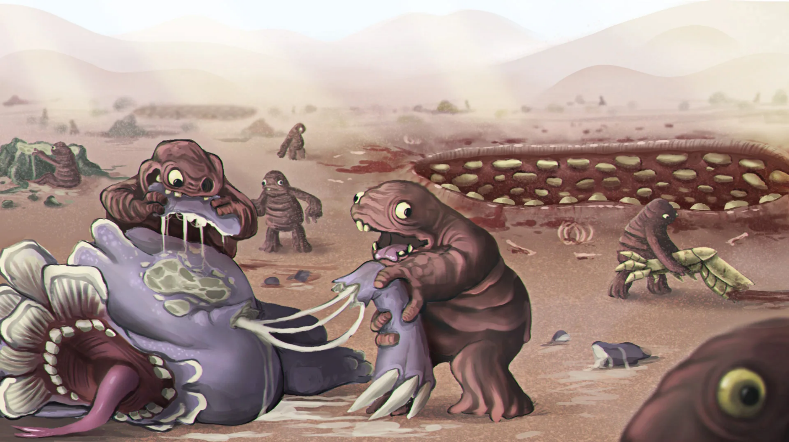

Flesh Golem

|  |  |  |  |  |  |  |  |
| --- | --- | --- | --- | --- | --- | --- | --- |
| MC | AC | T | P | W | A | F | Cost |
| 0.9 | 2.9 | 4 | 4 | 16 | 0 | 2 | 20 |

**Abilities:**

*Reshape 2*: The unit is malleable and can be recreated and changed by other units. X represents the current level.

Lorem ipsum dolor sit amet, consectetur adipiscing elit. Aliquam varius ligula vel tempor eleifend. Mauris nunc nulla, aliquam ac euismod at, bibendum sed sapien. Aenean nec condimentum odio. Pellentesque mauris nunc, mollis eu consectetur vitae, lobortis et ex. Aliquam pharetra, odio sit amet viverra pulvinar, velit velit rhoncus mi, et facilisis erat tortor quis risus. Quisque cursus congue sapien vel bibendum. Class aptent taciti sociosqu ad litora torquent per conubia nostra, per inceptos himenaeos. Quisque porttitor gravida condimentum. Mauris vel sollicitudin arcu. Nam eleifend dignissim libero egestas mollis. Phasellus nisi risus, viverra consequat eros quis, faucibus rhoncus massa. Cras vel leo eros.

Sed vitae ligula dapibus, interdum neque at, malesuada enim. Cras vitae nibh et libero vehicula euismod quis vel magna. Maecenas risus diam, sagittis sit amet ultrices non, hendrerit at nibh. Curabitur viverra elit vel ipsum laoreet, id hendrerit dui fringilla. Aenean finibus neque at nunc porttitor viverra. Ut facilisis ornare ex at interdum. Sed tristique, ante ac suscipit pulvinar, velit tellus placerat ligula, sed imperdiet nisi odio nec diam. Donec enim nisi, fermentum vel libero vulputate, aliquet condimentum odio. Phasellus faucibus interdum mi, nec hendrerit magna consequat quis. Mauris eget metus a nisl varius iaculis. Donec vulputate ligula vel justo tempus hendrerit. In enim augue, rutrum non pellentesque at, egestas ut ipsum. Phasellus auctor mi ut leo malesuada egestas. Vivamus in pellentesque orci, ac pulvinar mi. Curabitur vitae dictum velit.

Vestibulum nec sagittis nibh, in maximus ipsum. Suspendisse potenti. Nam non purus a magna convallis varius. Suspendisse sed felis lacus. Sed nisl massa, placerat vel est vitae, tristique dignissim dolor. Quisque feugiat sagittis lectus, ac porttitor est lobortis sed. Proin pellentesque eu erat non malesuada. Quisque fringilla in elit porta vehicula. Curabitur vel tincidunt urna. Suspendisse porta pharetra libero, sed placerat lectus pellentesque at. In sceleris



Flesh Behemoth

|  |  |  |  |  |  |  |  |
| --- | --- | --- | --- | --- | --- | --- | --- |
| MC | AC | T | P | W | A | F | Cost |
| 0.9 | 2.8 | 5 | 5 | 28 | 1 | 3 | 35 |

**Abilities:**

*Reshape 3*: The unit is malleable and can be recreated and changed by other units. X represents the current level.

Lorem ipsum dolor sit amet, consectetur adipiscing elit. Aliquam varius ligula vel tempor eleifend. Mauris nunc nulla, aliquam ac euismod at, bibendum sed sapien. Aenean nec condimentum odio. Pellentesque mauris nunc, mollis eu consectetur vitae, lobortis et ex. Aliquam pharetra, odio sit amet viverra pulvinar, velit velit rhoncus mi, et facilisis erat tortor quis risus. Quisque cursus congue sapien vel bibendum. Class aptent taciti sociosqu ad litora torquent per conubia nostra, per inceptos himenaeos. Quisque porttitor gravida condimentum. Mauris vel sollicitudin arcu. Nam eleifend dignissim libero egestas mollis. Phasellus nisi risus, viverra consequat eros quis, faucibus rhoncus massa. Cras vel leo eros.

Sed vitae ligula dapibus, interdum neque at, malesuada enim. Cras vitae nibh et libero vehicula euismod quis vel magna. Maecenas risus diam, sagittis sit amet ultrices non, hendrerit at nibh. Curabitur viverra elit vel ipsum laoreet, id hendrerit dui fringilla. Aenean finibus neque at nunc porttitor viverra. Ut facilisis ornare ex at interdum. Sed tristique, ante ac suscipit pulvinar, velit tellus placerat ligula, sed imperdiet nisi odio nec diam. Donec enim nisi, fermentum vel libero vulputate, aliquet condimentum odio. Phasellus faucibus interdum mi, nec hendrerit magna consequat quis. Mauris eget metus a nisl varius iaculis. Donec vulputate ligula vel justo tempus hendrerit. In enim augue, rutrum non pellentesque at, egestas ut ipsum. Phasellus auctor mi ut leo malesuada egestas. Vivamus in pellentesque orci, ac pulvinar mi. Curabitur vitae dictum velit.

Vestibulum nec sagittis nibh, in maximus ipsum. Suspendisse potenti. Nam non purus a magna convallis varius. Suspendisse sed felis lacus. Sed nisl massa, placerat vel est vitae, tristique dignissim dolor. Quisque feugiat sagittis lectus, ac porttitor est lobortis sed. Proin pellentesque eu erat non malesuada. Quisque fringilla in elit porta vehicula. Curabitur vel tincidunt urna. Suspendisse porta pharetra libero, sed placerat lectus pellentesque at. In sceleris

# FLESH BEHEMOTH IMAGE

Flesh Colossus

|  |  |  |  |  |  |  |  |
| --- | --- | --- | --- | --- | --- | --- | --- |
| MC | AC | T | P | W | A | F | Cost |
| 0.8 | 2.7 | 6 | 6 | 44 | 1 | 4 | 55 |

**Abilities:**

*Reshape 4*: The unit is malleable and can be recreated and changed by other units. X represents the current level.

Lorem ipsum dolor sit amet, consectetur adipiscing elit. Aliquam varius ligula vel tempor eleifend. Mauris nunc nulla, aliquam ac euismod at, bibendum sed sapien. Aenean nec condimentum odio. Pellentesque mauris nunc, mollis eu consectetur vitae, lobortis et ex. Aliquam pharetra, odio sit amet viverra pulvinar, velit velit rhoncus mi, et facilisis erat tortor quis risus. Quisque cursus congue sapien vel bibendum. Class aptent taciti sociosqu ad litora torquent per conubia nostra, per inceptos himenaeos. Quisque porttitor gravida condimentum. Mauris vel sollicitudin arcu. Nam eleifend dignissim libero egestas mollis. Phasellus nisi risus, viverra consequat eros quis, faucibus rhoncus massa. Cras vel leo eros.

Sed vitae ligula dapibus, interdum neque at, malesuada enim. Cras vitae nibh et libero vehicula euismod quis vel magna. Maecenas risus diam, sagittis sit amet ultrices non, hendrerit at nibh. Curabitur viverra elit vel ipsum laoreet, id hendrerit dui fringilla. Aenean finibus neque at nunc porttitor viverra. Ut facilisis ornare ex at interdum. Sed tristique, ante ac suscipit pulvinar, velit tellus placerat ligula, sed imperdiet nisi odio nec diam. Donec enim nisi, fermentum vel libero vulputate, aliquet condimentum odio. Phasellus faucibus interdum mi, nec hendrerit magna consequat quis. Mauris eget metus a nisl varius iaculis. Donec vulputate ligula vel justo tempus hendrerit. In enim augue, rutrum non pellentesque at, egestas ut ipsum. Phasellus auctor mi ut leo malesuada egestas. Vivamus in pellentesque orci, ac pulvinar mi. Curabitur vitae dictum velit.

Vestibulum nec sagittis nibh, in maximus ipsum. Suspendisse potenti. Nam non purus a magna convallis varius. Suspendisse sed felis lacus. Sed nisl massa, placerat vel est vitae, tristique dignissim dolor. Quisque feugiat sagittis lectus, ac porttitor est lobortis sed. Proin pellentesque eu erat non malesuada. Quisque fringilla in elit porta vehicula. Curabitur vel tincidunt urna. Suspendisse porta pharetra libero, sed placerat lectus pellentesque at. In sceleris



Flesh Titan

|  |  |  |  |  |  |  |  |
| --- | --- | --- | --- | --- | --- | --- | --- |
| MC | AC | T | P | W | A | F | Cost |
| 0.8 | 2.6 | 7 | 7 | 64 | 1 | 5 | 80 |

**Abilities:**

*Reshape 5*: The unit is malleable and can be recreated and changed by other units. X represents the current level.

Lorem ipsum dolor sit amet, consectetur adipiscing elit. Aliquam varius ligula vel tempor eleifend. Mauris nunc nulla, aliquam ac euismod at, bibendum sed sapien. Aenean nec condimentum odio. Pellentesque mauris nunc, mollis eu consectetur vitae, lobortis et ex. Aliquam pharetra, odio sit amet viverra pulvinar, velit velit rhoncus mi, et facilisis erat tortor quis risus. Quisque cursus congue sapien vel bibendum. Class aptent taciti sociosqu ad litora torquent per conubia nostra, per inceptos himenaeos. Quisque porttitor gravida condimentum. Mauris vel sollicitudin arcu. Nam eleifend dignissim libero egestas mollis. Phasellus nisi risus, viverra consequat eros quis, faucibus rhoncus massa. Cras vel leo eros.

Sed vitae ligula dapibus, interdum neque at, malesuada enim. Cras vitae nibh et libero vehicula euismod quis vel magna. Maecenas risus diam, sagittis sit amet ultrices non, hendrerit at nibh. Curabitur viverra elit vel ipsum laoreet, id hendrerit dui fringilla. Aenean finibus neque at nunc porttitor viverra. Ut facilisis ornare ex at interdum. Sed tristique, ante ac suscipit pulvinar, velit tellus placerat ligula, sed imperdiet nisi odio nec diam. Donec enim nisi, fermentum vel libero vulputate, aliquet condimentum odio. Phasellus faucibus interdum mi, nec hendrerit magna consequat quis. Mauris eget metus a nisl varius iaculis. Donec vulputate ligula vel justo tempus hendrerit. In enim augue, rutrum non pellentesque at, egestas ut ipsum. Phasellus auctor mi ut leo malesuada egestas. Vivamus in pellentesque orci, ac pulvinar mi. Curabitur vitae dictum velit.

Vestibulum nec sagittis nibh, in maximus ipsum. Suspendisse potenti. Nam non purus a magna convallis varius. Suspendisse sed felis lacus. Sed nisl massa, placerat vel est vitae, tristique dignissim dolor. Quisque feugiat sagittis lectus, ac porttitor est lobortis sed. Proin pellentesque eu erat non malesuada. Quisque fringilla in elit porta vehicula. Curabitur vel tincidunt urna. Suspendisse porta pharetra libero, sed placerat lectus pellentesque at. In sceleris



Shroomin

Shroomin live a peaceful idyllic existence in the dark damp corners of the world. Shroomin take a variety of shapes, but they are always some variety of mushroom. They are generally a meter or less in height, though some can grow to be almost man-sized. Outside of dedicated combatants, they tend to be soft and slow. Despite this, they have large populations anywhere the conditions allow it. In large part this is due to the Shroomin’s unique ability to reform themselves after death. Once spawned, it is notoriously difficult to permanently destroy a Shroomin. Upon death, their spores are released into the air, and given time will regrow the original creature. For non-Shroomin, the spores range from mild annoyances to incredibly deadly neurotoxins. Fighting Shroomin are not only deadly in death but are dangerous in life. If their rough teeth can’t tear through an enemy, then the poisons coating their bodies will slowly wear down their foes.

At the heart of each Shroomin village is a Mycelliform. The Mycelliform is the organism which creates all the Shroomin in the village. Each village is centered around its Mycelliform and expands outwards. Due to its immobile, underground nature, the villagers are responsible for acquiring matter to feed the Mycelliform and continue growth of the village. Shroomin are led by a council, consisting of their elder Shamans. Each Shaman is tasked with representing an aspect of the Mycelliform’s personality and arguing in support of that.

For the average Shroomin, life is a simple affair. They harvest matter to return to the village and tend to their crops. Young Shroomin are cared for by two or more older villagers until they can tend to themselves. It usually takes six weeks or so for the young to grow enough. As a Shroomin ages, parts of them fall off periodically and do not regenerate. These bits of genetic material are absorbed by growing Shroomin and in turn help to propagate good traits. In this way older Shroomin can continue their lines while helping the young. More than anything else, the Shroomin are a people who understand and exemplify the idea of the cycle of life. There is no true death for a Shroomin, as everything is recycled. No Shroomin is alone as they more than any others understand how all things rely on something else.



Grunt

|  |  |  |  |  |  |  |  |
| --- | --- | --- | --- | --- | --- | --- | --- |
| MC | AC | T | P | W | A | F | Cost |
| 1 | 3 | 2 | 2 | 6 | 0 | 2 | 7 |

**Abilities:**

*True Damage 1*: The unit cannot do fewer than one Damage with each Attack.

The Grunt makes up the core of any Shroomin force. Though they may not seem intimidating, and die easily, their danger lies inside. When killed, a Grunt explodes into a poisonous cloud of spores. If their enemy doesn’t disperse them, then in a few moments the Shroomin will reform itself ready to continue their relentless onslaught.

Grunts are physically somewhat larger than their noncombatant brethren, standing approximately five feet tall. They have dripping maws lined with jagged teeth and launch themselves forwards on ooze-covered appendages. Their bodies emit clouds of spores with each movement, making even the toughest armor a non-issue for them. They are formed as needed by the Mycelliform. Though necessary, their existence is one which is considered an unfortunate one by the Shroomin. The Grunts are not concerned with the opinions of their softer peers and view their existence as one of necessary conflict. As such, they have little concern for concepts like honor or fairness. Once the battle is over, their eventual fate is a return to the Mycelliform, where they will be reborn again when the time arises.



Sporeburster

|  |  |  |  |  |  |  |  |
| --- | --- | --- | --- | --- | --- | --- | --- |
| MC | AC | T | P | W | A | F | Cost |
| 1 | 3 | 2 | 2 | 7 | 0 | 2 | 9 |

**Abilities:**

*Reshape 3*: The unit is malleable and can be recreated and changed by other units. X represents the current level.

Lorem ipsum dolor sit amet, consectetur adipiscing elit. Aliquam varius ligula vel tempor eleifend. Mauris nunc nulla, aliquam ac euismod at, bibendum sed sapien. Aenean nec condimentum odio. Pellentesque mauris nunc, mollis eu consectetur vitae, lobortis et ex. Aliquam pharetra, odio sit amet viverra pulvinar, velit velit rhoncus mi, et facilisis erat tortor quis risus. Quisque cursus congue sapien vel bibendum. Class aptent taciti sociosqu ad litora torquent per conubia nostra, per inceptos himenaeos. Quisque porttitor gravida condimentum. Mauris vel sollicitudin arcu. Nam eleifend dignissim libero egestas mollis. Phasellus nisi risus, viverra consequat eros quis, faucibus rhoncus massa. Cras vel leo eros.

Sed vitae ligula dapibus, interdum neque at, malesuada enim. Cras vitae nibh et libero vehicula euismod quis vel magna. Maecenas risus diam, sagittis sit amet ultrices non, hendrerit at nibh. Curabitur viverra elit vel ipsum laoreet, id hendrerit dui fringilla. Aenean finibus neque at nunc porttitor viverra. Ut facilisis ornare ex at interdum. Sed tristique, ante ac suscipit pulvinar, velit tellus placerat ligula, sed imperdiet nisi odio nec diam. Donec enim nisi, fermentum vel libero vulputate, aliquet condimentum odio. Phasellus faucibus interdum mi, nec hendrerit magna consequat quis. Mauris eget metus a nisl varius iaculis. Donec vulputate ligula vel justo tempus hendrerit. In enim augue, rutrum non pellentesque at, egestas ut ipsum. Phasellus auctor mi ut leo malesuada egestas. Vivamus in pellentesque orci, ac pulvinar mi. Curabitur vitae dictum velit.

Vestibulum nec sagittis nibh, in maximus ipsum. Suspendisse potenti. Nam non purus a magna convallis varius. Suspendisse sed felis lacus. Sed nisl massa, placerat vel est vitae, tristique dignissim dolor. Quisque feugiat sagittis lectus, ac porttitor est lobortis sed. Proin pellentesque eu erat non malesuada. Quisque fringilla in elit porta vehicula. Curabitur vel tincidunt urna. Suspendisse porta pharetra libero, sed placerat lectus pellentesque at. In sceleris



Shaman

|  |  |  |  |  |  |  |  |
| --- | --- | --- | --- | --- | --- | --- | --- |
| MC | AC | T | P | W | A | F | Cost |
| 1.5 | 3 | 2 | 2 | 10 | 0 | 2 | 10 |

**Abilities:**

*Reshape 3*: The unit is malleable and can be recreated and changed by other units. X represents the current level.

Lorem ipsum dolor sit amet, consectetur adipiscing elit. Aliquam varius ligula vel tempor eleifend. Mauris nunc nulla, aliquam ac euismod at, bibendum sed sapien. Aenean nec condimentum odio. Pellentesque mauris nunc, mollis eu consectetur vitae, lobortis et ex. Aliquam pharetra, odio sit amet viverra pulvinar, velit velit rhoncus mi, et facilisis erat tortor quis risus. Quisque cursus congue sapien vel bibendum. Class aptent taciti sociosqu ad litora torquent per conubia nostra, per inceptos himenaeos. Quisque porttitor gravida condimentum. Mauris vel sollicitudin arcu. Nam eleifend dignissim libero egestas mollis. Phasellus nisi risus, viverra consequat eros quis, faucibus rhoncus massa. Cras vel leo eros.

Sed vitae ligula dapibus, interdum neque at, malesuada enim. Cras vitae nibh et libero vehicula euismod quis vel magna. Maecenas risus diam, sagittis sit amet ultrices non, hendrerit at nibh. Curabitur viverra elit vel ipsum laoreet, id hendrerit dui fringilla. Aenean finibus neque at nunc porttitor viverra. Ut facilisis ornare ex at interdum. Sed tristique, ante ac suscipit pulvinar, velit tellus placerat ligula, sed imperdiet nisi odio nec diam. Donec enim nisi, fermentum vel libero vulputate, aliquet condimentum odio. Phasellus faucibus interdum mi, nec hendrerit magna consequat quis. Mauris eget metus a nisl varius iaculis. Donec vulputate ligula vel justo tempus hendrerit. In enim augue, rutrum non pellentesque at, egestas ut ipsum. Phasellus auctor mi ut leo malesuada egestas. Vivamus in pellentesque orci, ac pulvinar mi. Curabitur vitae dictum velit.

Vestibulum nec sagittis nibh, in maximus ipsum. Suspendisse potenti. Nam non purus a magna convallis varius. Suspendisse sed felis lacus. Sed nisl massa, placerat vel est vitae, tristique dignissim dolor. Quisque feugiat sagittis lectus, ac porttitor est lobortis sed. Proin pellentesque eu erat non malesuada. Quisque fringilla in elit porta vehicula. Curabitur vel tincidunt urna. Suspendisse porta pharetra libero, sed placerat lectus pellentesque at. In sceleris

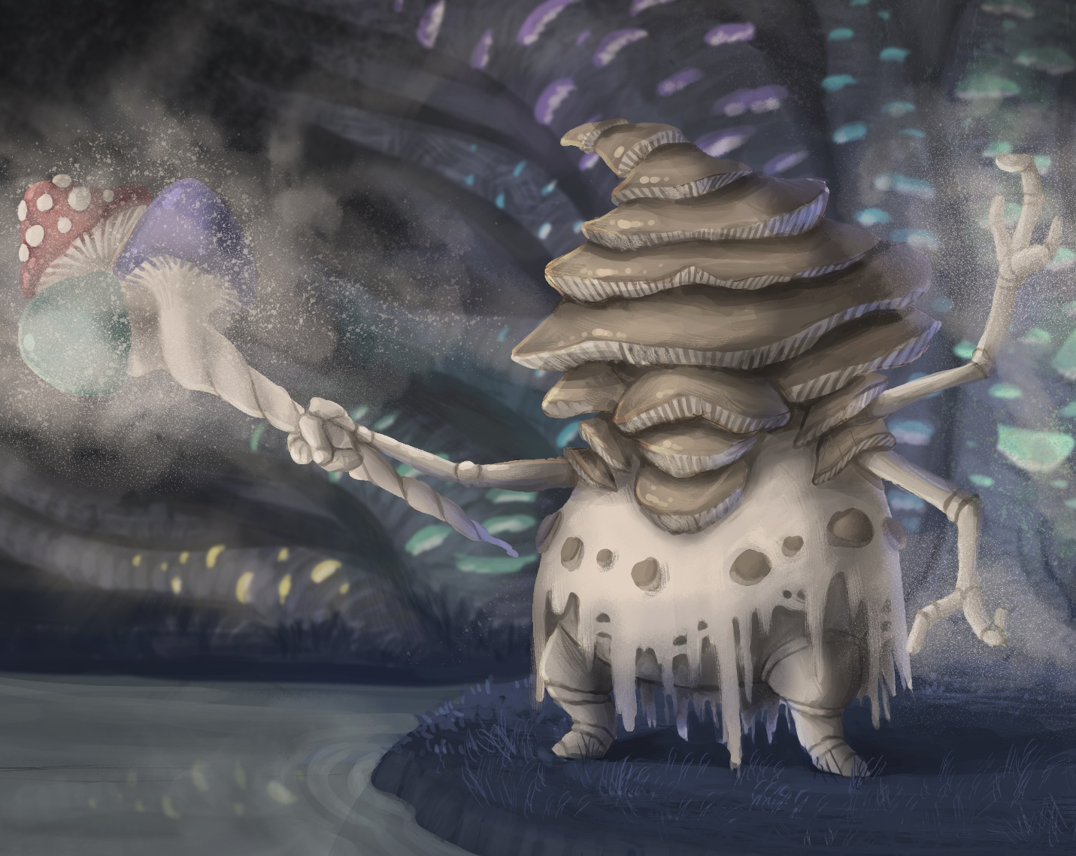Hydra

|  |  |  |  |  |  |  |  |
| --- | --- | --- | --- | --- | --- | --- | --- |
| MC | AC | T | P | W | A | F | Cost |
| 1.5 | 3 | 2 | 2 | 10 | 0 | 2 | 10 |

**Abilities:**

*Reshape 3*: The unit is malleable and can be recreated and changed by other units. X represents the current level.

Lorem ipsum dolor sit amet, consectetur adipiscing elit. Aliquam varius ligula vel tempor eleifend. Mauris nunc nulla, aliquam ac euismod at, bibendum sed sapien. Aenean nec condimentum odio. Pellentesque mauris nunc, mollis eu consectetur vitae, lobortis et ex. Aliquam pharetra, odio sit amet viverra pulvinar, velit velit rhoncus mi, et facilisis erat tortor quis risus. Quisque cursus congue sapien vel bibendum. Class aptent taciti sociosqu ad litora torquent per conubia nostra, per inceptos himenaeos. Quisque porttitor gravida condimentum. Mauris vel sollicitudin arcu. Nam eleifend dignissim libero egestas mollis. Phasellus nisi risus, viverra consequat eros quis, faucibus rhoncus massa. Cras vel leo eros.

Sed vitae ligula dapibus, interdum neque at, malesuada enim. Cras vitae nibh et libero vehicula euismod quis vel magna. Maecenas risus diam, sagittis sit amet ultrices non, hendrerit at nibh. Curabitur viverra elit vel ipsum laoreet, id hendrerit dui fringilla. Aenean finibus neque at nunc porttitor viverra. Ut facilisis ornare ex at interdum. Sed tristique, ante ac suscipit pulvinar, velit tellus placerat ligula, sed imperdiet nisi odio nec diam. Donec enim nisi, fermentum vel libero vulputate, aliquet condimentum odio. Phasellus faucibus interdum mi, nec hendrerit magna consequat quis. Mauris eget metus a nisl varius iaculis. Donec vulputate ligula vel justo tempus hendrerit. In enim augue, rutrum non pellentesque at, egestas ut ipsum. Phasellus auctor mi ut leo malesuada egestas. Vivamus in pellentesque orci, ac pulvinar mi. Curabitur vitae dictum velit.

Vestibulum nec sagittis nibh, in maximus ipsum. Suspendisse potenti. Nam non purus a magna convallis varius. Suspendisse sed felis lacus. Sed nisl massa, placerat vel est vitae, tristique dignissim dolor. Quisque feugiat sagittis lectus, ac porttitor est lobortis sed. Proin pellentesque eu erat non malesuada. Quisque fringilla in elit porta vehicula. Curabitur vel tincidunt urna. Suspendisse porta pharetra libero, sed placerat lectus pellentesque at. In sceleris

# UNIT IMAGE

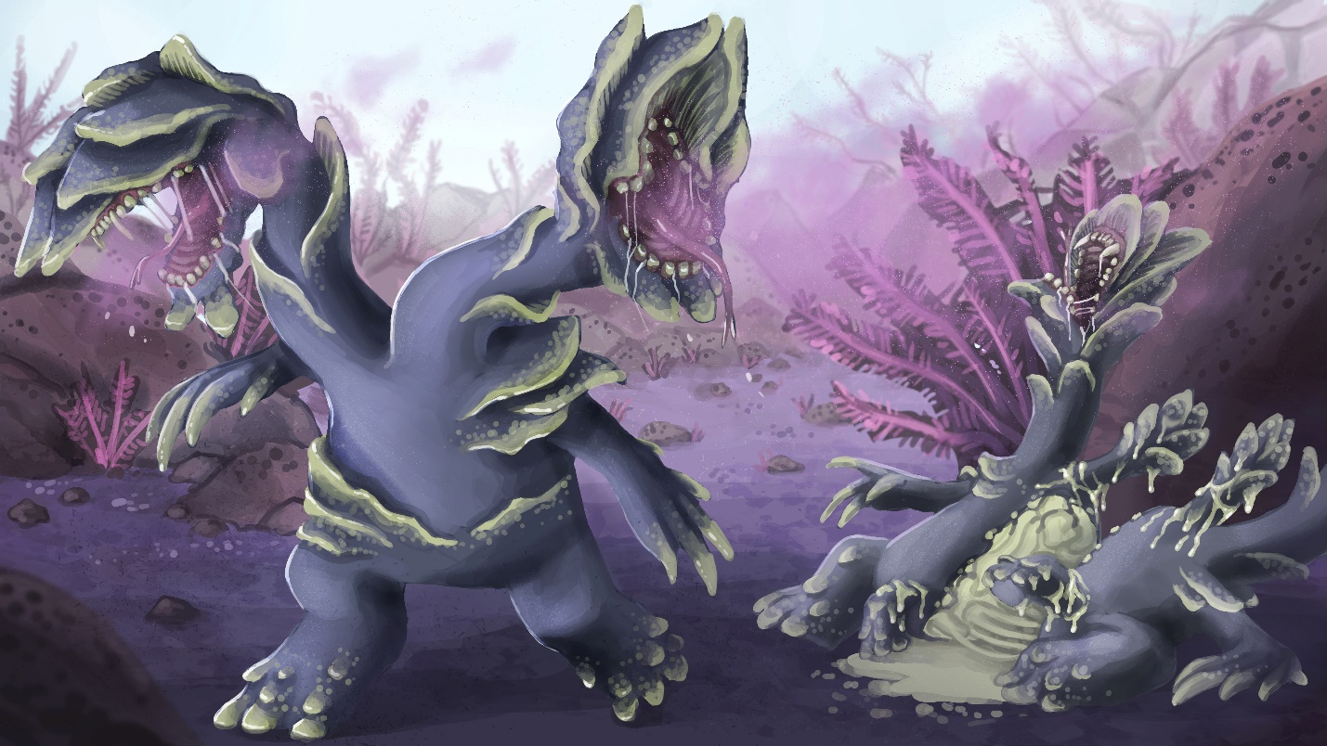

Morlocks

Lorem ipsum dolor sit amet, consectetur adipiscing elit. Aliquam varius ligula vel tempor eleifend. Mauris nunc nulla, aliquam ac euismod at, bibendum sed sapien. Aenean nec condimentum odio. Pellentesque mauris nunc, mollis eu consectetur vitae, lobortis et ex. Aliquam pharetra, odio sit amet viverra pulvinar, velit velit rhoncus mi, et facilisis erat tortor quis risus. Quisque cursus congue sapien vel bibendum. Class aptent taciti sociosqu ad litora torquent per conubia nostra, per inceptos himenaeos. Quisque porttitor gravida condimentum. Mauris vel sollicitudin arcu. Nam eleifend dignissim libero egestas mollis. Phasellus nisi risus, viverra consequat eros quis, faucibus rhoncus massa. Cras vel leo eros.

Sed vitae ligula dapibus, interdum neque at, malesuada enim. Cras vitae nibh et libero vehicula euismod quis vel magna. Maecenas risus diam, sagittis sit amet ultrices non, hendrerit at nibh. Curabitur viverra elit vel ipsum laoreet, id hendrerit dui fringilla. Aenean finibus neque at nunc porttitor viverra. Ut facilisis ornare ex at interdum. Sed tristique, ante ac suscipit pulvinar, velit tellus placerat ligula, sed imperdiet nisi odio nec diam. Donec enim nisi, fermentum vel libero vulputate, aliquet condimentum odio. Phasellus faucibus interdum mi, nec hendrerit magna consequat quis. Mauris eget metus a nisl varius iaculis. Donec vulputate ligula vel justo tempus hendrerit. In enim augue, rutrum non pellentesque at, egestas ut ipsum. Phasellus auctor mi ut leo malesuada egestas. Vivamus in pellentesque orci, ac pulvinar mi. Curabitur vitae dictum velit.

Vestibulum nec sagittis nibh, in maximus ipsum. Suspendisse potenti. Nam non purus a magna convallis varius. Suspendisse sed felis lacus. Sed nisl massa, placerat vel est vitae, tristique dignissim dolor. Quisque feugiat sagittis lectus, ac porttitor est lobortis sed. Proin pellentesque eu erat non malesuada. Quisque fringilla in elit porta vehicula. Curabitur vel tincidunt urna. Suspendisse porta pharetra libero, sed placerat lectus pellentesque at. In sceleris

Raider

|  |  |  |  |  |  |  |  |
| --- | --- | --- | --- | --- | --- | --- | --- |
| MC | AC | T | P | W | A | F | Cost |
| 1.5 | 3 | 2 | 4 | 6 | 2 | 2 | 10 |

**Abilities:**

*Enhanced Burrow* : As Burrow. When this unit burrows, it gains two inches of movement for each inch taken during a Movement Action. Additionally, when the unit emerges from a burrow, if it Charges it may count the sum of its Burrow distance as its movement.

Quick and deadly, the Raider composes the bulk of the Morlock forces. Raiders are fast, tenacious and opportunistic. Raiders are adept tunnellers and can quickly cross large distances unimpeded by terrain. They will often wait for long periods of time, before striking suddenly in numbers upon a single point. With their powerful cutting implements and momentous charges even the most powerful enemies can be taken down.

The appearance of an individual Raider varies, depending upon its host. However, many of them eventually form into a large worm-like creature. With each victory, Raiders are given the opportunity to feast on the corpses of the slain. For this reason, they particularly enjoy raids against the Fleshcrafter domains. Morlocks are kept in a perpetual state of hunger due to their high metabolic rates and the energy requirements to maintain subjugation of their hosts. They are not simply driven by animal desire, however.

The Raiders consider battle prowess a virtue and see a large battle record as proof of that. In this way, the more proof of battle a Raider has the more recognition and esteem they get. Typical signs are scars or the increased size that comes with multiple feasts. Due to their high mortality rates and short lives, Raiders take a grim practical outlook on life. They accept death as an inevitability and seek to maximize their personal legend before they die.

Saboteur

|  |  |  |  |  |  |  |  |
| --- | --- | --- | --- | --- | --- | --- | --- |
| MC | AC | T | P | W | A | F | Cost |
| 1 | 3 | 2 | 2 | 6 | 0 | 2 | 7 |

**Abilities:**

*Enhanced Burrow* : As Burrow. When this unit burrows, it gains two inches of movement for each inch taken during a Movement Action. Additionally, when the unit emerges from a burrow, if it Charges it may count the sum of its Burrow distance as its movement.

*Lay Mine* : During this units move, if it is burrowed, for every three inches moved it may choose to expend a Focus Point to deploy a mine token. Each mine token is a 1-inch token which detonates in a 3-inch explosion with 5 Strength and AP 3 (3R, 5S, AP3).

Lorem ipsum dolor sit amet, consectetur adipiscing elit. Aliquam varius ligula vel tempor eleifend. Mauris nunc nulla, aliquam ac euismod at, bibendum sed sapien. Aenean nec condimentum odio. Pellentesque mauris nunc, mollis eu consectetur vitae, lobortis et ex. Aliquam pharetra, odio sit amet viverra pulvinar, velit velit rhoncus mi, et facilisis erat tortor quis risus. Quisque cursus congue sapien vel bibendum. Class aptent taciti sociosqu ad litora torquent per conubia nostra, per inceptos himenaeos. Quisque porttitor gravida condimentum. Mauris vel sollicitudin arcu. Nam eleifend dignissim libero egestas mollis. Phasellus nisi risus, viverra consequat eros quis, faucibus rhoncus massa. Cras vel leo eros.

Sed vitae ligula dapibus, interdum neque at, malesuada enim. Cras vitae nibh et libero vehicula euismod quis vel magna. Maecenas risus diam, sagittis sit amet ultrices non, hendrerit at nibh. Curabitur viverra elit vel ipsum laoreet, id hendrerit dui fringilla. Aenean finibus neque at nunc porttitor viverra. Ut facilisis ornare ex at interdum. Sed tristique, ante ac suscipit pulvinar, velit tellus placerat ligula, sed imperdiet nisi odio nec diam. Donec enim nisi, fermentum vel libero vulputate, aliquet condimentum odio. Phasellus faucibus interdum mi, nec hendrerit magna consequat quis. Mauris eget metus a nisl varius iaculis. Donec vulputate ligula vel justo tempus hendrerit. In enim augue, rutrum non pellentesque at, egestas ut ipsum. Phasellus auctor mi ut leo malesuada egestas. Vivamus in pellentesque orci, ac pulvinar mi. Curabitur vitae dictum velit.

Vestibulum nec sagittis nibh, in maximus ipsum. Suspendisse potenti. Nam non purus a magna convallis varius. Suspendisse sed felis lacus. Sed nisl massa, placerat vel est vitae, tristique dignissim dolor. Quisque feugiat sagittis lectus, ac porttitor est lobortis sed. Proin pellentesque eu erat non malesuada. Quisque fringilla in elit porta vehicula. Curabitur vel tincidunt urna. Suspendisse porta pharetra libero, sed placerat lectus pellentesque at. In sceleris